Long Eaton & District Branch February 2017

Hello everyone.

May I start by thanking all those who sent good wishes to me and Jen during and after my unexpected stays in QMC last year. I am considerably better now and hoping for a less disrupted year in 2017!

Next month (March 9th) is the AGM and three of our longest serving committee members will be standing down. Dorothy Mills, Gordon Mason and Sue Brown have all been heavily involved with our local branch since it was founded in 1999. Their input in all sorts of ways has been invaluable to many branch members past and present. We thank them for their contribution and hope that we shall continue to see them at meetings and other events in the future. Dorothy celebrated her 90th birthday recently. Many congratulations from us all at Long Eaton branch.

At the AGM we formally welcome on to the committee two new members, Colin Muge and Mark Hyman. Colin has in fact been acting as Branch Treasurer since the start of the year, for which I personally am extremely grateful! Mark has over the last couple of years been helping unofficially in various ways and has allowed himself to ‘be volunteered’ by me to join us as a committee member. If anyone else is interested in becoming a committee member, please don’t hesitate to let us know. Alternatively, lots of people can make an active contribution to the branch in many less obvious, but very important roles without necessarily joining the committee. Whatever you can offer is much appreciated.

We start 2017 in a very healthy position, financially, in branch membership numbers and in terms of the activities we have on offer. At the time of writing we have in our accounts over £15,000, which means that we continue to have the capacity to subsidise outings, meals, exercise classes etc. In addition we have already sent since the start of the year £1,000 to Parkinson’s UK as a contribution to national initiatives. We asked on this occasion for the money to be divided equally between medical research and Parkinson’s nurses.

I must mention here the particular contribution made by Mary and Bri an following their art exhibitions. They have generously donated over £2,000 to our branch, a sum which has been increased by a further £500+ from the greetings cards which Jen has made featuring the paintings. Add on Gift Aid of 25% and the grand total comes to a figure well over £3,000. Mary and Brian specifically requested that these funds should be used to set up therapy sessions, in the areas of singing, dance, speech therapy and similar related activities. This aim came a little closer to being realised with the visit of Caroline Bartliff and Claire Johnson, speech and occupational therapists, from the Royal Derby Hospital to the February branch meeting. A working group will be exploring various ways in which we can put these plans into practice.

The February branch meeting was attended by 60 people, an even higher figure than usual. The exercise classes have attracted an average total of 27/28 members, plus a dozen carers, so about 40 people per week are enjoying our branch activities. In fact the total number of members who attend the various events in the course of the year is between 90 and 100! We must be doing something right! On that basis the money taken in per session is almost equal to the cost of room hire and fees. A small, but intrepid number of members take part in Nordic Walking (especially recommended for Parkinson’s sufferers) in West Park, Long Eaton on Thursday mornings. Please contact Graham Beech on 07713948833 for further details.

A few places have become available for both Monday and Friday exercise classes. Unfortunately, Sue Brown, who set up the exercise classes several years ago, is no longer able to attend due to Alan’s illness. May I on behalf of all those who have taken part and benefitted from these classes thank Sue for her personal commitment and initiative. We hope that Alan will continue to recover from his stroke and wish for them both a happier year than 2016.

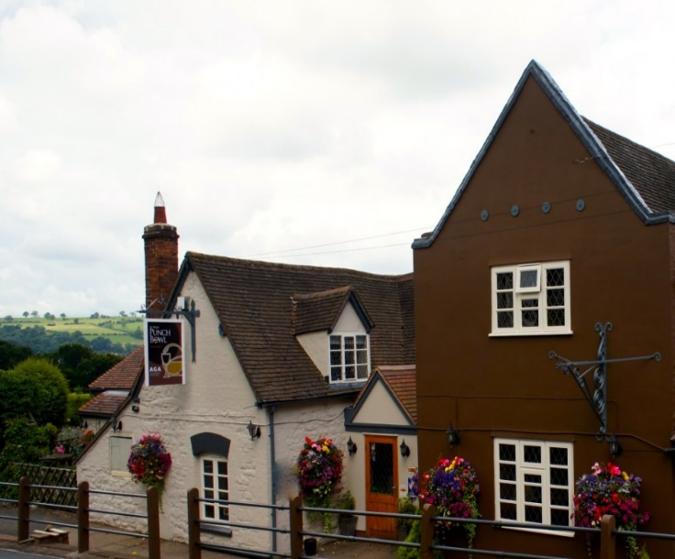
Several very successful outings took place last year. Judging from comments I have received, the visit to the Severn Valley Railway was particularly enjoyable. For some the carvery beforehand at Ye Olde Punchbowl, Bridgnorth (pictured left) seemed to be even more memorable than taking a trip on a steam train!

The Christmas lunch at Trent Lock Golf Centre was well received, as in previous years. A provisional booking has already been made for Monday, 4th December this year.

The first outing of 2017 has been proposed for Thursday, April 27th. This would involve a carvery lunch at The Grouse, Darley Dale with the final destination to be decided on the day, depending on the weather. Possibilities include Bakewell or Matlock/Matlock Bath. In the event of bad weather we might consider Masson Mills or the Peak Shopping Village. Connoisseurs of carveries may be able to make a comparison with that of last year! The cost is a very reasonable £9.00 per person. Demand is likely to exceed the coach capacity of 50 people, so it will have be “first come, first served” at the AGM/branch meeting on March 9th. Don’t forget it’s a 1.30 start again (and well done to the vast majority who did remember the early start at the last meeting!!)

We have been conscious for some time of a gap in Parkinson’s services in the area centred around Beeston, partly due to the fact that the Nottingham Branch activities are based in the east of the city. In fact, around 35% of our branch membership live in Nottinghamshire but find Long Eaton more convenient to reach. Sheila has managed to acquire funding of £960 to set up a “Parkinson’s Café” in Beeston to provide a focal point where people can drop in for a drink and a chat on an informal basis. The café will be open for the first time on Saturday, March 18th from 10.00 till 12.00 at the Catholic Church Hall, Foster Avenue, Beeston, NG9 1AE. This first event will incorporate an Information Day at which support staff from Parkinson’s UK will be present. After that the café will be open on a monthly basis on the second Saturday of every month. Your support would be much appreciated if you are able to pop in.

Parkinson’s Awareness Week takes place this year from 10th to 16th April. This may seem an odd choice of timing as it runs into Easter weekend. The reason for this is that this week marks the 200th anniversary of the publication of Dr. Parkinson’s treatise on the “shaking palsy” as he called it. We have been lucky indeed to be offered the use of Long Eaton ASDA premises for the second year running to publicise Awareness Week. However, there were some problems about the clash with Easter, so we are celebrating the event a week earlier between 3rd and 9th April. I have been able to book the Imari Ladies’ Chorus to sing at ASDA from 11.30 till 12.00 on Saturday, 8th April, which should certainly attract the customers’ attention! Other features of the week may include a display of Nordic Walking and fundraising by volunteers from Long Eaton School packing customers’ bags at the tills.

Sheila’s niece will be taking part in the Great North Run in September and is hoping to raise money for Parkinson’s UK. Please see Sheila if you would like to sponsor her.

SPECIAL OFFER: Sheila also has details of a 2-year-old electric reclining chair, fabric in crushed strawberry, full working order, available FREE OF CHARGE!

The provisional programme for the next few branch meetings can be found below.

Schedule of branch meetings 2017

March 9th | AGM | NB: 1.30 start!
April 13th | Beeston Ukulele Band
May 11th | Steven Flinders | Local historian  Katherine Crompton’s Diary
June 8th | Razzle Dazzle | Female singing duo
July 13th | Mrs. O’Brian | Nepal and the Earthquake
August 10th | Social meeting | Chance for a chat!
September 14th | Table top sale | Bring anything you like to buy and sell
October 12th | Rosemary Muge | Poaching in the East Midlands
November 9th | To be arranged
December 14th | Christmas Social

All branch meetings are held at Risley Memorial Hall from 2-4pm. (2nd Thursday in the month)
The exercise classes continue on Mondays and Fridays at CVS, Granville Avenue(1.30-2.30)
The next committee meeting is at Toc H on March 14th.

Some useful contacts for further information:

John Shirt (Chair) 0115 972 8085
johnshirt541@yahoo.com 07730677949

Sheila North (Vice-chair): 01158498490 sheila.north1@btopenworld.com

Stuart Bancroft (Membership) 0115 972 2852
Stuart06@live.co.uk

Marion Drage (Transport) 0115 939 9932
mariondrage@icloud.com

Lorraine Ray (Volunteer Coordinator) 03442259850
vc.east2@parkinsons.org.uk

Karen Bown (Local Adviser – Erewash) 03442253629 adviser8.central@parkinsons.org.uk

Cate Woodward (Local Adviser – Notts.) 03442253749 adviser3.central@parkinsons.org.uk

Jo Mist (Exercise Class Instructor) 07976415185

Graham Beech (Nordic Walking Instructor) 07713948833

