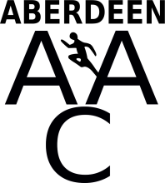
ABERDEEN AMATEUR ATHLETIC CLUB
SUMMER ATHLETICS CAMP
Wednesday 9th, Thursday 10th and Friday 11th August 2017 1.30pm -3.30pm
Aberdeen Sports Village
Cost : £30 per athlete
Suitable for children in P6, P7, S1
Contact: R Watson pathways@aberdeenaac.co.uk to book your place M: 07857130921

