**Hockey News January 2017**

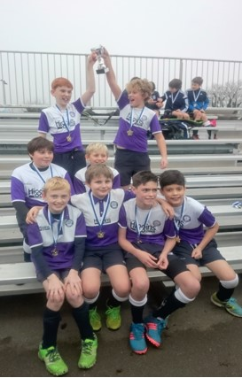

Welcome back to everyone after the Christmas break. Hopefully you’ll feel refreshed and eager to go. The second half of the season is always very busy, so buckle up and prepare for a whirlwind of hockey.

**The Season So Far**

We’ve played 3 sets of Essex Tournaments and a number of friendlies, including the U8’s against Waltham Forest and the U12’s Girls against Bedford school. We’ve fielded 11 teams and have fulfilled every fixture which is testament to the commitment of the players, their parents and coaches. Our primary aim is to get as many children playing hockey as possible and this seems to be working.

Of particular note is the success we’ve had at the Surbiton U13’s Tournament, where our U12’s Girls and Boys fielded teams. The Girls did really well and held their own, despite the age difference whilst the Boys had a fantastic day and came away as Champions. They celebrated in style by filling their winners’ cup with strawberry milkshake!

This success continued over the Christmas period at the Copper Box. It was a great day and quite an experience to be part of. The U10’s Boys came 3rd, the U12’s Boys narrowly lost out in the final on extra time shuffles to Canterbury (their first loss of the season) and the U10’s Girls were winners of their age group with a very impressive 3-0 victory in the final. It was particularly great to see them all doing a celebratory dance with their coach after they won!

So, onwards and upwards towards the Essex Cups!

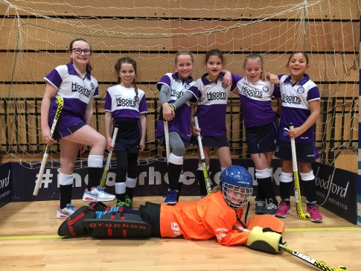

**What to have in your Stick Bag**

Having played myself for many years, there are things as adults we often take for granted. We assume everyone has all that’s needed in their hockey stick bags to see us through every eventuality.

Below is a list of helpful items which it would be useful to include in your child’s hockey stick bag:

1. Stick (goes without saying, although I have been to matched and found it missing)
2. Gum Shield

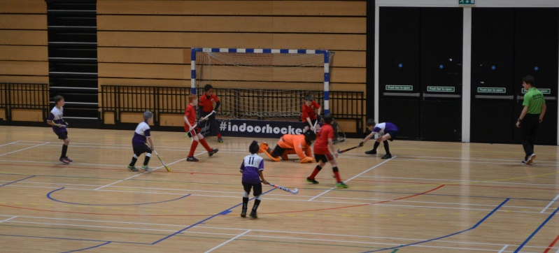

1. Shin pads
2. Electrical take (for sticking grips on, numbers on shirts, taping goalies into kit)
3. Hockey gloves or cycling gloves for cold weather
4. Single use ice pack
5. Small first aid kit with plasters and wipes
6. List of phone numbers for emergency contacts
7. One or two hockey balls
8. Leggings/track suit/jumper/shower proof top
9. Hair bands/clips
10. Water bottle

**Dates for the diary for Jan-May**

Friendlies Boys and Girls U10’s and U12’s Home vs Blue Hearts 8th January

Boys U12’s Home vs Seven Oaks 22nd January

U8’s Mixed vs Bishop Stortford (dates TBC)

Essex League: 29th January 2017



19th February 2017

19th March 2017

Essex Cup U10 Girls and U12 Boys 26th March

U12 Girls and U10 Boys 12th March

Regional Finals 8th and 9th April

Easter Break 8th and 15th April No Training

Training restarts 22nd April

Old Loughts Tournament 1st May

Last Training and Presentation 20th May

2017-18 Season restarts Sept (date TBC)

**Mini Council**

The Mini’s council will meet for the first time on Saturday 14th January after training. Other Mini’s will have the opportunity to pass on opinions to these representatives who will discuss those points at the meeting. This will be overseen by Jill Bowyer and Mary-Jane Crowley. The first committee will be made up of:

1. Toby Gayler
2. Nathan Gladman

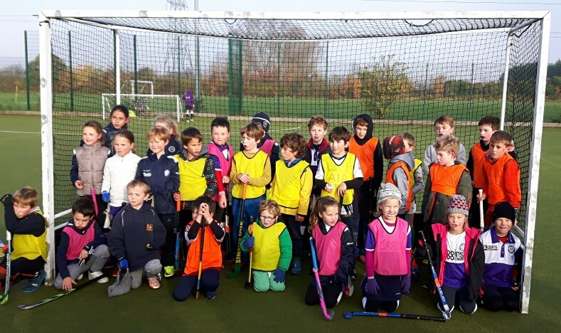

1. Anya Pitt
2. Nancy Pierre
3. Zara Gardezi
4. Agnes Briscoe
5. Cameron Martin
6. Fergus Martin

**Website**

Please make sure you have logged onto the website and checked contacts and ***added medical details***, as this are where coaches will gather all the necessary information about players. There is also a Photo Gallery where you can see what the Mini’s have been up to. This should make life simpler for managers as you are able to add to your child’s profile, making sure medical information, emails and contact numbers are correct. If you don’t have a login, please email Peter Kempe ([p.kempe@taylorwessing.com](mailto:p.kempe@taylorwessing.com) )directly as he will be able to send out a new invite if yours has expired. <http://olhc.clubbuzz.co.uk/>

**Fund Raising**

Our ongoing project of ‘Old Loughts Bunting’ will make reappearance at the Meet and Greet Desk in the next few weeks. We had last year’s up at the Copper Box for the indoor tournament and it looked FAB! Mini’s are asked to contributed £1 per triangle to cover the cost of the materials for the bunting, they then take this away to decorate. We ask the Mini’s to be as creative as they like but we would like you to add your name so in years to come we can all look back and see who played for our club.

**A reminder for Saturday morning training**

Can I remind all parents that the register for Saturday attendance is kept at the **Meet and Greet Desk** which will be at the entrance to the club house. It is essential that **ALL Mini’s** report to the desk **BEFORE** going to the pitches. This will allow us to have a reliable register in case of an emergency. It is also an easy way to pass on information, return lost property and check availability for matches. Children in the U8’s/Seedlings groups will need to register at the desk **with** their parents.

**Lost Property**

Please can parents name items of clothing as we have large amounts of lost property? At the end of each term we sell unclaimed item. This money is then added to the Mini Fund Raising Account. If you lost something last term feel free to check at the Meet and Greet Desk and this will be returned to you, otherwise we will include all lost property in the sale.

**Training Times:**

* Seedlings School Years 1-2 9.30 – 10.30 am Green Pitch Near End
* U8’s School Years 2-3 9.30 – 10.45 am Green Pitch Far End
* U10’s School Years 4-5 9.30 – 11.00 am Girls Pitch 1 / Boys Pitch 2
* U12’s School Years 6-7 9.30 – 11.00 am Girls Pitch 1 / Boys Pitch 2

**Bad Weather**

In the event of bad weather, check the Website and Twitter (<https://twitter.com/miniloughts>)

**Safeguarding**

Mary-Jane Crowley is the Club Safeguarding Officer, if you have any concerns this please contact her on:

[Maryjanec17@gmail.com](mailto:Maryjanec17@gmail.com) 07885297823

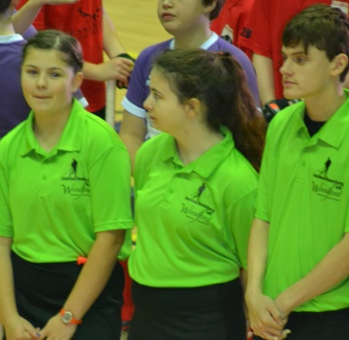

**And finally!**

Do you recognise these faces? Well done to Molly, Roxy and Zak who continue to take their umpiring to the next level. They all took part in the indoor tournament on New Years Day.

Sam Gayler ([samantha.gayler@virginmedia.com](mailto:samantha.gayler@virginmedia.com))