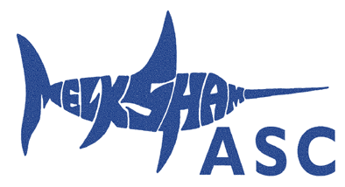
Melksham ASC Standard Entry Form for Open Meets
Name of Open Meet: Swindon Dolphins Level 3 – 28th + 29th July 2018
Closing date 11-May-2018
Name: | Male/Female:
DoB: | ASA Registration No:
Email: | Telephone no:

Event | Entry Time
50 Freestyle
100 Freestyle (10+ years only)
200 Freestyle
400 Freestyle
50 Breaststroke
100 Breaststroke (10+ years only)
200 Breaststroke
50 Butterfly
100 Butterfly (10+ years only)
200 Butterfly
50 Backstroke
100 Backstroke (10+ years only)
200 Backstroke
100 IM
200 IM
400 IM
Number of entries x cost per event (£5.50) | £
Entry forms must be completed and returned before the closing date. Please return to Mike Wood(competitionsecretary@melkshamswordfish.org.uk)
Cheques payable to Melksham ASC, alternatively you may pay by direct bank transfer to the following account (preferred):
Account #: 02023765
Sort code : 309875
Reference: Abbreviated swimmer’s surname & meet name e.g. BEN CAL for Benson, Calne

If paying by direct bank transfer please confirm by email to competitionsecretary@melkshamswordfish.org.uk

