Stragglers Green Belt Relay Odyssey 2018

For many runners, this writer included, the Stragglers Greenbelt Relay weekend is the highlight of the racing calendar. 220 miles around London in a single weekend with teams of 11 completing the 22 stages, each team member covering two of those stages, ranging from the relatively benign sections of road and path to the rather 'hilly' trail sections covering parts of the route. This race is not for everyone. Some don't like running on two days or prefer road racing or are put off by the degree of navigation required en-route. For others, however, it is a true running Odyssey but substituting Ulysses and his journey home after the fall of Troy, with a team of Stragglers racing from Hampton Court Palace to the Hawker Centre, via Essex.
As you would expect with such an epic there are many challenges to overcome, the first one being able to field three complete teams in our case men, ladies and vets. This year we really were jinxed by illness and injury forcing many withdrawals along the way. The week leading up to the race resembled the end of the Trojan wars, with three more runners dropping out due to injury (the final one on Friday lunchtime, before the Saturday start!). At this point it looked like we had run out of options and the Ladies team would have become the 'Straggler ladies and Phil Davies Team'. With less than 12 hours to go, Emily Cartwright came to the rescue, following an urgent Twitter and Facebook appeal. The issue though, was that Emily needed a dog minder for her new puppy 'Nutmeg'. So a deal was struck, it was 'walkies' for Phil, and our ladies team was complete again.
At 8:30 on Saturday morning, at a gloriously sunny Hampton Court Palace the race was underway with the first 12 miles to Staines ahead of the runners (with a record 50 teams on the start line). The Stragglers would be handing over to Simon Brazil, Phil Tauwhare and Laura Bowden respectively who were tackling a new section of the course around Windsor necessitated by Royal events over the other side of the river. (Both Simon and Laura can now claim to have set Straggler records for the men and ladies respectively). With this stage completed without incident, the race was well underway with temperatures beginning to rise significantly.
Stage 3 having been tackled, the baton was then passed on to the Stragglers completing stage 4 from Marlow (a grade 10 stage on account of having to run across half the Chilterns!) Rob Wilcox, Martin Vivian and Helen Davies took this one on. All three had excellent races, in particular Rob who recorded 3rd place overall in the race (and then repeating the feat the next day, running from Box Hill!) a great achievement. Stage 5, another Grade 10 and the longest on the course at 13.5 miles saw a very good performance from Oli Bowers but this was overshadowed by Sarah Winter finishing 16 and setting an L35 record for that stage and narrowly missing out on being first lady. With the Chipperfield stage safely negotiated, the St Albans (stage 7) saw Richard Carter pull out a great performance for the Vets finishing 7th on that leg. Crispin Allen managed to go one better at Letty Green with a 5th place finish for the Vets closely pursued by Richard Baggott for the Men.
By the time Dobbs Weir (stage 9) was underway, temperatures were mercifully starting to drop as the runners headed for the shade at High Beach. Stage 10 then took runners through the cool of Epping Forest before arriving at Toot Hill and a great favourite of the Stragglers, the Green Man pub! Leg 11 to Blackmore in Essex marks the final stage of Day one and the chance for a drink and a debrief.

By this halfway point the men were sitting in 14th position overall in the race. The Vets were in ninth place, having opened up a significant gap on the Elmbridge Grey Hares and the British Airways Veterans (insert your own joke here about the Stragglers Vets really flying!). The Ladies for their part were also second in their category but had an ever so slender lead of 15 minutes over Ranelagh Ladies going into Day Two, with everything to play for.
Stage 12 from Blackmore starts at the rather unsociable time of 8 AM on Sunday with Simon Webb and Brazil having joked that they might as well have not bothered to go to bed. Even less daunted was Crispin Allen, running the next leg, who managed to better his performance from the Saturday finishing second overall in the race and setting a Vet course record into the bargain and only missing out on winning the stage by 11 seconds. Cranham (Stage 14) is the race towards the River Thames and the QE2 bridge and was particularly keenly contested by the Stragglers. Roy Reeder finishing ninth missed out on the M50 record by a couple of seconds. Helen Davies can count herself even more unlucky, finishing third lady behind Jackie Balfour running for BMF and Ange Norris of Dulwich Runners with only seven seconds separating all three runners and remarkably all of these runners breaking the L45 record for that stage by over 3 minutes.
Once across the Thames it was the ladies leading the way. Sarah Winter managed to better her Saturday run by finishing eighth overall and ‘doing the double’ by setting another L35 stage record. Next up was the infamous Lullingstone Park stage 16 (13.3 miles of hills). For the ladies Maddie Garner had a particularly good run, commendable as she knew what she was letting herself in for (having done it last year). Another special mention goes to Peter Wedderburn running for the men who, having been drafted in at the last minute, had drawn the short straw with this leg!
By this stage we were back in Surrey with the start of the next leg in Tatsfield. Whilst Oli Bowers and Malcolm Davies were battling it out, it was left to Ramona Thevenet to grab the headlines with a L55 record on this stage (and a mention in Athletics Weekly!). Next up was Merstham, another particularly tough stage involving running up Box Hill! Stage 19 runs down the hill but then straight up the North Downs on the other side! There were three particularly good performances here the aforementioned Rob Wilcox, Jim Desmond for the vets and Juli Greenwood for the ladies all recording good finishing positions. It's all downhill from there, on stage 20 with Richard Carter finishing an overall 7th place and then Andy Howarth and Emily Cartwright battling it out to finish in 26th and 28th position respectively.
The penultimate stage is Ripley to Walton Bridge led home by Martin Vivian in 13th place. The final leg is the one that everyone wants, Walton Bridge to the waiting crowds and adulation at the Hawker centre. The honour of taking this leg fell to Dan Greenslade finishing in 9th place, Rob Greenwood for the men and Laura Bowden for the ladies.
Whilst everyone recovered, there was an anxious wait to get the final results after two days racing. For the men a final position of 17th was confirmed in a cumulative time of 1 day, 4 hours and 31 minutes, a good result. The Vets had confirmed a 10th place overall of 1 day, 2 hours and 38 minutes, putting the Vets into second place in their category and grabbing the runners up prize. Last, but not least, the Ladies found they had finished 35th overall in 1 day, 6 hours and 29 minutes. This result had put them 49 minutes in front of Ranelagh Ladies and confirmed their second place overall in the ladies competition, a cue for celebrations all round!
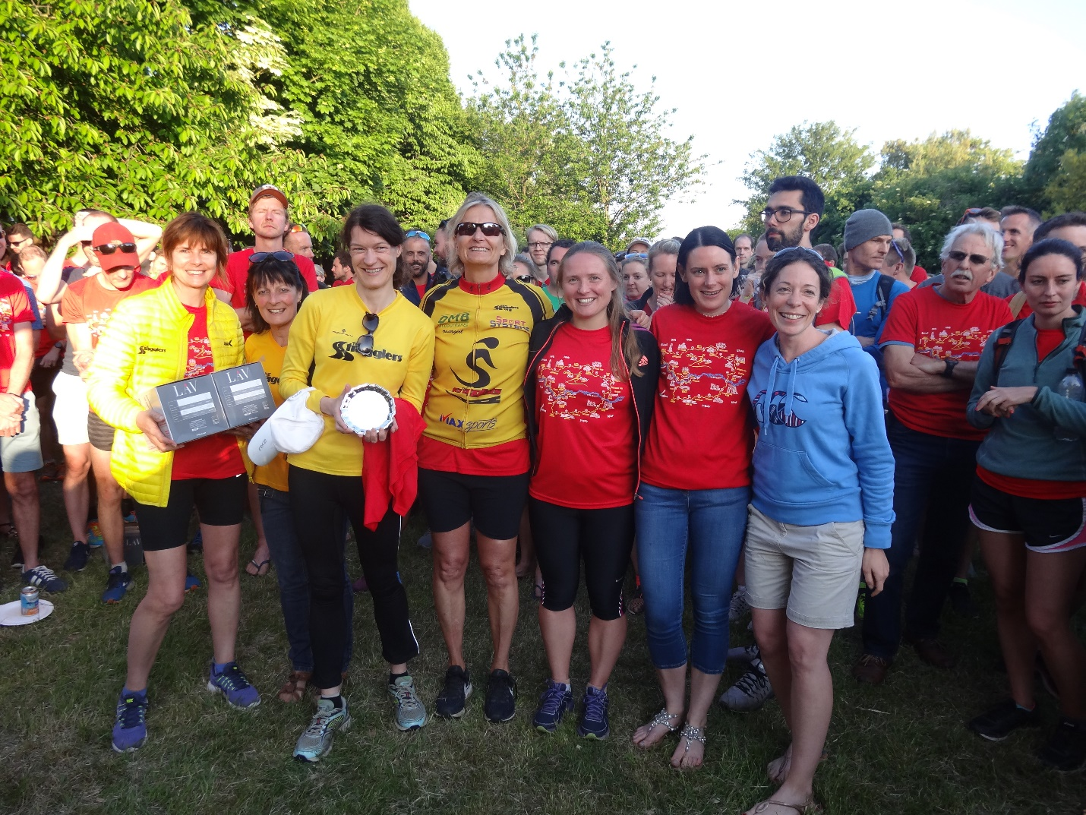
Straggler Ladies taking second prize
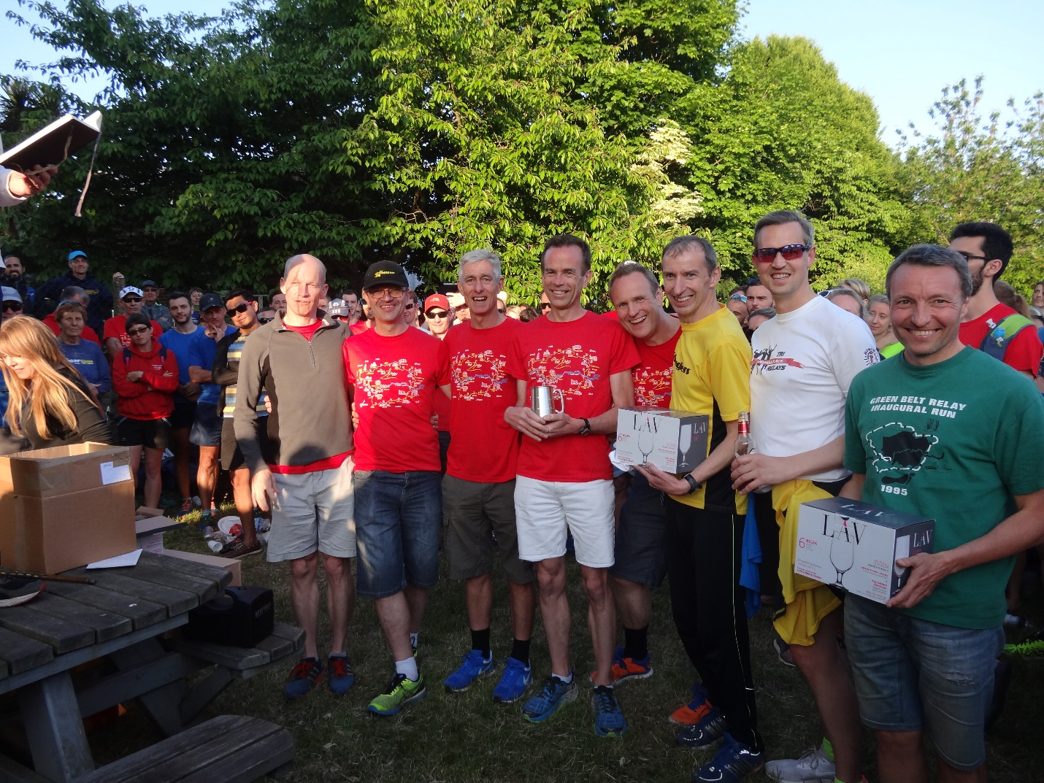
Straggler Vets Grabbing Second Place
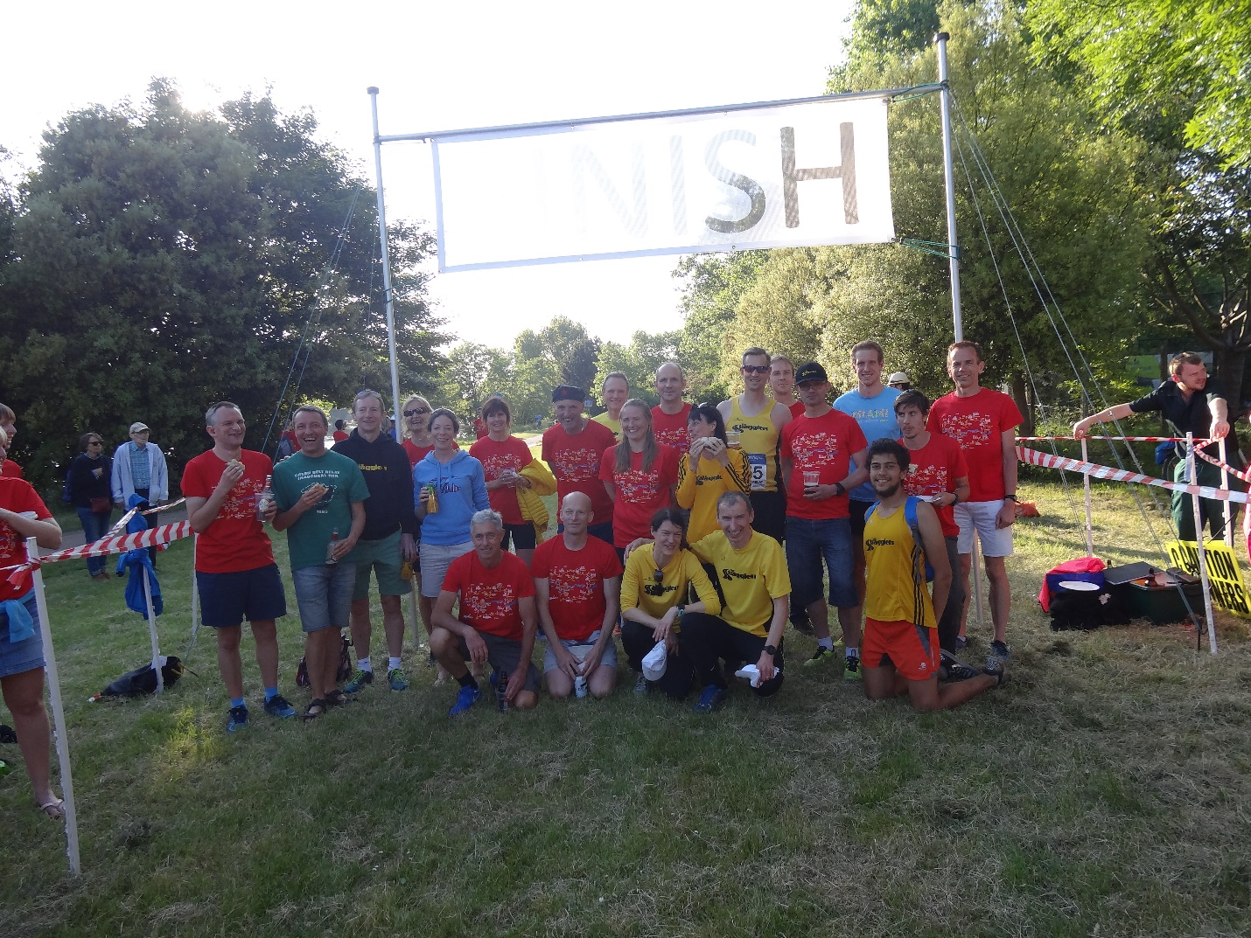
A welcome sight: The finish line!

Thank you to everyone involved, the Straggler volunteers, marshals, course markers, timekeepers and of course Peter Kennedy and Alex Cutting and the organising committee for making it a brilliant weekend for the club.

A special thank you to the 33 Straggler runners who did the club proud as follows:
Vet's Team | Men's Team | Ladies' Team
Dan Greenslade | Simon Webb | Juli Greenwood
Simon Brazil | Phil Tauwhare | Laura Bowden
Jim Desmond | Rob Greenwood | Lindsay Doy
Martin Vivian | Rob Wilcox | Helen Davies
Malcolm Davies | Oli Bowers | Sarah Winter
Kevin Price | Fraser Wigley | Emily Cartwright
Richard Carter | Andy Howarth | Ramona Thevenet
Crispin Allen | Richard Baggott | Mary Hyde
Stephen Penpraze | Peter Wedderburn | Julie Holmes
Roy Reeder | Neil Carrington | Maddie Garner
Mark Pattinson | Richard Patient | Julie Haworth

