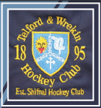

As last year’s junior members and Parents will recall Telford and Wrekin Hockey Club offered all junior members a training shirt upon receipt of the annual subs or agreed payment plan. Following the success of this we are looking to do something similar.

Many of you will be aware of the heightened awareness the impact of plastics is having on the environment on land and at sea.
Follow the uncomfortable images on Sir David Attenborough‘s Blue Plant program the media has really raised latched on to the size of the issue.

We at the club would also like to do our bit. So help keep the area tidy and reduce plastic waste we will be issuing reusable drink bottles with the club logo and players initials.

These bottles have been kindly sponsored by local business, in conjunction with the club and are worth in the region of £10
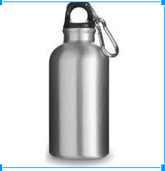

How do you get yours?

If you are a paid up junior member then we will be issuing you with your drink bottle shortly afterward receipt

For those members who aren’t junior members, we would love you to support the campaign and the bottles will be available via the club shop.

