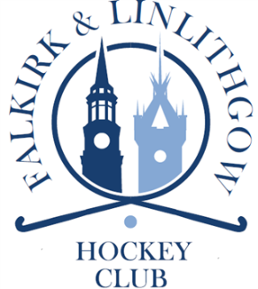
Hockey Development Coach

An opportunity has arisen for up to 2 self-employed Hockey Development Coaches within the structure of Falkirk & Linlithgow Hockey Club (FLHC) to deliver youth development sessions in the geographical areas of Grangemouth and Linlithgow. This is initially a four year programme, which is designed to increase youth hockey participation at all age levels, for both male and female.

Services required:
- Liaise with the multiple partners of FLHC to introduce an in-school and after-school programme in a designated “cluster “ (high school plus feeder primaries)
- Provide extracurricular school coaching sessions and contribute to the growth of hockey in the cluster by supporting schools with taster sessions and festivals.
- Increase the levels of youth membership in FLHC by supporting the pathway from school to club training.
- Provide statistics on participation and transition from school to club programmes.

Responsible to:
The Chair of The Executive Committee, FLHC

Essential Qualifications:
All sessions must be led by a coach with (or in the process of working towards):
- UKCC Level 2 or equivalent
- at least 2 years coaching experience
- current First Aid and PVG qualifications
- membership of the Association of Scottish Hockey Coaches or another insuring body

Additional Details:
- Rate of remuneration will be agreed in accordance with the level of qualification and experience as well as the number or hours of coaching and administration services provided
- In the first instance, an introduction to partners and schools will take place from May 2019. The post is for the provision of circa 1 x 24 hours or 2 x 12 hours per week of coaching services, from August 2019 – June 2023.
- The position is self-employed with support offered to the successful candidate to enable this.

If you have any questions please contact Michael Watson on the enclosed email address
To apply please submit a CV to: chair@falkirkandlinlithgowhockeyclub
CLOSING DATE: 19th April 2019

