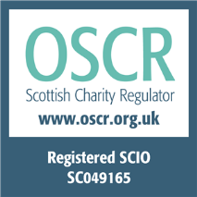
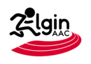
ELGIN AMATEUR
ATHLETIC CLUB

ATHLETE’S CODE OF CONDUCT

Elgin Amateur Athletic Club is committed to safeguarding and promoting the wellbeing of all its members. The club believes that it is important that members, coaches, committee members and parents associated with the club, should at all times show respect and understanding for the safety and welfare of others. Members are encouraged to be open at all times and to share any concerns or complaints that they may have about any aspect of the club with Coach, President or Welfare Officer.

- Listen to the coaches and obey all rules, particularly with regard to Health & Safety.

- Any illnesses or injuries suffered by a member must be reported to their coach at the earliest convenience and medical information form must be completed

- Treat others with the same respect and fairness that you wish to receive. Be considerate to others, work as a team and respect opponents and team mates

- All property belonging to EAAC must be carefully used and stored at all times

- It is the athletes’ responsibility to apply for competitions on time. All competitors will wear a club vest when representing EAAC

- Never accept lifts in cars without the prior knowledge of your parent/guardian

- Members are not allowed to smoke, consume alcohol or take drugs of any kind on club premises or whilst representing the club. If you use an inhaler or take any prescription drugs you must fill out the appropriate form (available from a member of the committee). Random drug tests may be administered at any formal competition

