BLAZE JUNIOR
MEMBERSHIP PACK

Please contact
blazejuniors@outlook.com
for further details

Dear New Club Member,
On behalf of Blaze Netball Club we would like to welcome your daughter to the club and provide you with some information about our activities. The junior section of our club provides opportunities for young people between the ages of 8 and 15 years to receive netball coaching and competition.
All coaching is delivered or supervised by qualified coaches and all have valid DBS checks. The club has a safeguarding officer Sharon Walker who will deal with any safeguarding concerns.
The aims of Blaze Netball Club are:
1. To promote and develop the game of netball for all age groups.
2. To promote competition and encourage a competitive spirit within a structured framework.
3. To promote mass participation.
4. To encourage fair play and sportsmanship.
5. To play all matches in accordance with the rules of England Netball.
6. To adopt England Netball duty of care guidelines for netball clubs and associations including child protection guidelines.

We welcome parents to all training and competitions and value your support. We are keen to try and involve parents in the club. Let us know if you have any free time to help out.
Training sessions take place on Wednesday Evenings, Bishopshalt Secondary School from 6.00-8.00 p.m. Sessions are outdoors so please ensure that your child is adequately dressed for the weather. Arrangements should be made for your child to travel to and from training sessions and matches.
We appreciate it if children can arrive promptly and are collected promptly at the end of the session, if they are not making their own way home. If you are going to be late picking your child up, please contact your daughters coach.
We would be grateful if you could complete the attached club membership registration form & medical form. For the safety of your child it is important that the club is informed of any medical condition or allergies that may be relevant should your child fall ill or be involved in an accident while at the club. This is also replicated on our club website so access is available for all coaches and for reference.
If you would like to talk to someone at the club about this information or your child’s involvement with the club, please contact...
blazejuniors@outlook.com.
Contents
NEW MEMBERS INFORMATION 3
Club Website 3
Club joining Fee 3
Subscriptions 3
Training 3
Medical Matters 3
Kit 4
Volunteers 4
Joining Checklist: 4
MEMBERSHIP FORMS 5
6.8 Codes of Conduct for Parents & Carers 7
6.1 Codes of Conduct for Athletes 9

NEW MEMBERS INFORMATION
This information is designed to give you a brief outline of everything you need to know, but please ask if you have any further questions. Included is a Registration and Medical Form which you should complete and return as soon as possible with your first terms subscriptions.

Club Website
Our club website is: www.blazenetballclub.co.uk
Match fixtures, announcements and team selection will always be available on the club website. Members must join and create their own profile via the email they offer on this joining form (preferably a parent’s email address). The member’s area is private and available to both adult and junior members. Please visit regularly to ensure that you keep abreast of club news. Following on from this our social media accounts also have regular updates…
Facebook: Blaze Netball Instagram: blazenetballclub Twitter: BlazeNetball

Club joining Fee
This cost is to cover England Netball and Middlesex Netball Membership & Affiliation. Benefits include merchandise discounts, magazines and Comprehensive Liability and Personal Accident insurance cover.
https://www.englandnetball.co.uk/membership/membership-benefits/

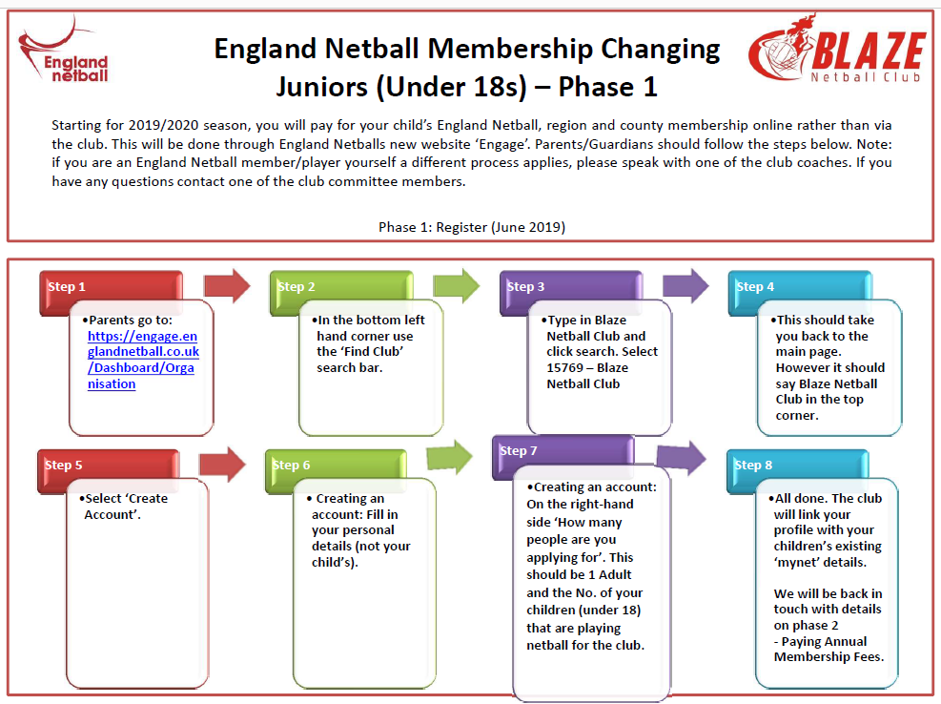

Subscriptions
The junior section subscription is payable at the beginning of each term, the cost is £30.00 per term excluding the first term which is £40.00.
This must be paid via online bank transfer to...
Account Name: Blaze Netball Club
Account Number: 81880381
Sort Code: 40-42-08
Please use your Daughter's FULL NAME as the Payee reference.

Training
Training is on a Wednesday during term time at Bishopshalt Secondary School, Royal Lane, Uxbridge, Middlesex UB8 3RF.
Training is between 6-8pm and age groups training times are tbc in due course.
The outdoor courts are visible upon entry by the school gates (to the right). Please make sure cars are parked in the car park, to the left when you drive in, rather than right next to the courts. Changing room and toilet access is available in the school. Training is roughly scheduled with term time except half terms, Christmas, Easter and summer holidays. Other exceptions will be listed on our website. We do like you to attend training as often as possible, but of course we understand that there are some weeks that you just can’t make. Training is very important to develop and improve everyone’s netball skills and for members to benefit from being part of a club. We do try to have matches during the last part of training, which gives everyone a good practise for the real thing.
If you are not going to be able to attend training then we do ask that you inform the relevant Coach or email blazejuniors@outlook.com.

Medical Matters
Blaze NC are following the Football Association’s lead on management of medical conditions. All children that are reported as affected by Asthma will be expected to bring their inhalers to ALL matches and training labelled with their names and GIVE them to the coach or PLACE in the designated area for the duration of the session. The same applies to any children with conditions that may require Epi Pens or other quick response interventions.

Kit
For all matches players are required to wear a Blaze Netball Dress which will need to be purchased from the website under ‘All Things Kit’. If you would like your name on the dress this needs to be done by adding the personalisation option and then place your child’s name in the comments. Players will also be given a t-shirt when they complete their membership which they should wear to training and put over their dress on match days. Players should wear their own shorts/leggings/long-sleeved top under the dress.
At training you should wear appropriate sports clothing and wear a specific sports bra during training and matches. We also recommend that you invest in a good pair of trainers, preferably netball or tennis specific ones. This is to increase the longevity of the sole as they are designed to withstand the ‘wear and tear’ caused by multidirectional movement on court surfaces.
Kit supplier http://blazenetballclub.bigcartel.com/
Blaze Hoodies and weather proof jackets and trousers are also available to purchase from our kit supplier. The link is also available on the News page of our website.

Volunteers
If you wish to help on social committee or volunteer at training, please email blazenetballclub@yahoo.co.uk. We always love help to organise social events, tournaments, awards nights, kit washing and team management!
Parents – to pass the time whilst waiting for training/games to finish … try your hand at umpiring or coaching! Why not? – Please let your coaches know, they would love to help.

Joining Checklist:

- Log onto the England Membership Engage website to complete club affiliation to England and Middlesex – without doing this you will not be able to play any games.
- Pay your 1st Terms subscription of £40.00 (after this each term will be £30.00) into the club account.
- Completed a Membership Form, Medical Form and Codes of Conduct.
- Hand membership forms in an envelope clearly marked with your child’s name and coach or age group they are joining.
- Log in and update member profile on Website

We hope you all have a great time being part of Blaze Netball Club!
Many thanks and do not hesitate to contact our head of Juniors if you wish to discuss anything.
Alison Summerfield
07789 900048

MEMBERSHIP FORMS
PLease complete all Details in Block Capitals & Return To YOUR JUNIOR COACH

Welcome to Blaze. We are a netball club open to players from eight years of age.
To ensure we have the correct contact details for you, please fill out this form and return to your main coach

section a:

PLAYERtails
First Name |  |  |  | Surname
Address
 |  |  |  |  | Postcode
Telephone |  |  |  |  | School/ College
Date of Birth  (DD/MM/YY) |  |  |  |  | County of Birth
Are you a member of any other sports club?
(If yes, please state which club and which sport)
1st position
2nd position
Playing experience

SECTION B: PARENT/CARER DETAILS
If you are under 16 years of age, please ask your parent/carer to complete the complete the following section.
First Name |  |  |  | Surname
Address
 |  |  | Postcode
Telephone |  |  | Mobile Number
Email Address

SECTION C: PARENT/CARER HELP
One of the conditions of membership of Blaze Netball is that we ask all parents /carers to help out at club events for a few hours each year. Please tick areas that you would be interested in helping with. The relevant club person will then contact you to see which events you would be able to help at. If there is a specific area of expertise that you feel you can bring to the club, please also indicate below.

Helping at Netball tournaments/fixtures |  |  | Assisting Training
Refreshment area |  |  | Team management
Fund raising |  |  | Supervision of athletes
Facility/Equipment maintenance |  |  | Committee post  (Expect a call from HQ!)
Website management
Promotion and marketing |  |  | Helping Officials
Other (please specify) | NOW PLEASE CONTINUE THE FORM OVER THE PAGE

section D: Medical information
Please detail below any important medical information that our coaches/junior coordinator should be aware of (e.g. epilepsy, asthma, diabetes, allergies etc.) Please do not leave blank – if there is no information please write ‘None’.

section e: Emergency contact details
Please insert the information below to indicate the persons who should be contacted in event of an incident/accident.
Emergency Contact One Name
Emergency One Contact number:
Emergency Contact Two Name
Emergency Contact Two number:

It may be essential at some time for authorised persons acting on behalf of the club to have the necessary authority to obtain urgent treatment which may be required whilst at representative club competition or training. Please sign below to give your consent to emergency treatment being given to the named athlete on this form by trained personnel

Signature
Print Name

section f: Athlete AGREEMENT
By returning this completed form, I am willing to abide by the club code of conduct for athletes and agree to always behave in the manner befitting a Blaze Netball Athlete, when attending club events and external fixtures.

Signature
Print Name

section g: PaRENTAL/carer AGREEMENT
By returning this completed form, I agree:

1. To the named athlete taking part in the activities of the club.
2. That I have read and agree to abide by the club code of conduct whenever I am present at club activities or competition
3. To helping out at club events and fixtures each year.
4. To give consent for my daughter to be photographed and videoed by Blaze Netball club for promotional material, newspaper stories and on the Blaze Website

Signature
Print Name
We look forward to welcoming you and your family to the club in the near future. To find out all the latest club information, please visit our website www.blazenetballclub.co.uk

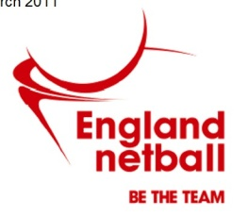
EN Disciplinary Regulations August 2018

Codes of Conduct for Parents & Carers
EN has Codes of Conduct across the sport which is driven by its’ core values of leadership, integrity, teamwork and excellence. Our codes require the highest standards of conduct from everyone involved in netball to ensure that their behaviour and actions meet the values and standards expected of them at all times. The enjoyment and safety of your child when they are involved in a netball activity is of paramount importance to EN. Every child will be encouraged and asked to ensure that their behaviour and actions meet the values and standards expected of them at all times. As parents, you are also asked to support our Codes of Conduct and embrace the spirit of our game.
As a parent/carer, I will:

- Encourage my child to play within the rules and respect officials’ and coaches’ decisions

- Support my child’s efforts and performance, give positive comments that motivate and encourage continued effort and learning

- Understand that competition is about winning and losing, so results are always accepted without undue disappointment

- Be a positive role model to my child by helping them work towards skill improvement and good sportsmanship

- Remember that children learn best by example; I will applaud good play by both my child’s team and their opponents

- Thank the coaches, officials and other volunteers who give their time for my child and not interfere with their decisions

- Help when asked by a coach or official

- Respect the rights, dignity and worth of all people involved in the game, regardless of gender, marital status, race, colour, disability, sexuality, age, occupation, religion or political opinion

- Read the rules of the sport to understand better what I am watching and discussing with my child

- Promote this code of conduct to other parents, carers and supporters

- Be aware of my child’s club safeguarding policy and ensure that any concerns are reported to the club’s safeguarding officer or England Netball’s Lead Safeguarding Officer.

As a parent/carer, I will not:

- Pressure my child in any way; I know that this is their sport not mine

- Use inappropriate language, harass athletes, coaches, officials or other spectators

- Criticise or ridicule my child for making a mistake or losing after the game

- Force my child if they are unwilling to participate in the sport

- Arrive at a netball activity under the influence of alcohol or drugs

- Use Social Media technology to bring the game into disrepute or make an inappropriate comment about an athlete, coach, official, volunteer or member of England Netball staff

- Consume illegal substances either immediately prior to or while being at a netball activity where my child is participating in the sport

- Consume alcoholic drinks or smoke either immediately prior to or while being at a netball activity where my child is participating.

………………………….………………………………..…….……. ………………………………………………………………………….. ……………………………..
Parent/Carer Name (print) Signature Date
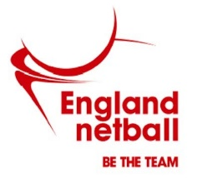
EN Disciplinary Regulations August 2018

Codes of Conduct for Athletes
EN has Codes of Conduct across all aspects of the sport, which is driven by its’ core values of leadership, integrity, teamwork and excellence. Our codes require the highest standards of conduct from everyone involved in Netball to ensure that their behaviour and actions meet the values and standards expected of them at all times.

Netball Sport ethic: Respect, Teamwork, Achievement and Fun

By abiding by these Codes of Conduct, netball players can achieve respect, good sportsmanship, high standards of behaviour and ethics to provide them with an enjoyable, safe and stimulating experience.
Everyone must conduct themselves in an honest, fair, impartial and transparent manner.

I …………………………………………..………..……………………………. will Respect:
Player’s name

- The rules, regulations and requirements of the Sport, including, but not limited to, any competitions in which I participate either directly or indirectly

- The rights, dignity and worth of all people involved in netball, regardless of gender, marital status, race, colour, disability, sexuality, age, occupation, religion or political opinion

- Netball and the individual’s reputation and not take any action or make inappropriate comments about a fellow participant, coach, official, volunteer or member of England Netball’s staff that will bring the Sport or those associated with delivering the Sport into disrepute, including making comments on social media technology. I will respect EN’s guidance and policies on social media technology.

- The position I hold within Netball and always conduct and dress myself in an appropriate manner.

- The result of the game and will not attempt to offer, offer or accept either directly or indirectly any consideration whatsoever in return for influencing or attempting to influence the result or seek to achieve personal gain on a result which I can influence by betting on any match or event where I am participating, either by playing, coaching or officiating, or through direct or indirect involvement.

Netball is based on Teamwork, therefore I will:

- Not abuse or misuse any relationship of trust or position of power or influence held by me in my team, be that my playing team, Club, County, Regional or England Netball

- Be on time, dressed appropriately and ready to give my full attention to the role I am carrying out within Netball

- Recognise that individuals bring different qualities and attributes but “together we will excel”.

- Welcome new members, volunteers, and connected participation and cooperate with Members, Connected Participants, colleagues, coaches, officials and administrators already in the Sport.

I recognise individuals participate in Netball to achieve and have fun, therefore I will:

- Recognise the achievements of others and applaud their successes

- Endeavour to ensure that all involved in the Sport optimise their potential by promoting the positive aspects of the sport and never condoning the use of inappropriate or abusive language, inappropriate relationships, bullying, harassment, discrimination or physical violence.

- Not impinge on others enjoyment of the Sport or my performance by consuming alcoholic drinks or smoke immediately prior to or while participating in the sport, or while safeguarding children, young people or vulnerable adults

- Ensure that everyone has the opportunity to participate in a fair, honest environment by rejecting cheating, abiding by the Anti-Doping policies and not taking illegal substances immediately prior to or while participating in the Sport.

- Display modesty in victory and graciousness in defeat; be sporting – whether I win or lose; always acknowledge the other team and the umpires at the end of the game with a hand shake or three cheers.

- Never argue with an official or participant during a game and listen to and cooperate with officials’ decisions

- Control my temper; I understand that verbal, emotional and physical abuse of officials, coaches, spectators or participants, or deliberately distracting or provoking a participant, coach or official is not acceptable or permitted behaviour in netball

- Enjoy the game and ensure other can also enjoy it.

I will endeavour to abide by these codes of conduct and promote them to others.
I understand that if I fail to follow the code, then England Netball, the Regional Association or the County Association may take action against me under the Disciplinary Regulations which may result in Sanctions including fines and suspension.

Player’s Signature: ………………………………………………………………………………. Date: …………………………………….………

Player Name (Print): …………………………………………………..

Social Media Acceptable Use Agreement

EN Disciplinary Regulations August 2018

This Agreement is to be read by parents/carers and the young person, in order to ensure the obligations are understood before signing.
Blaze Netball Club understands the importance of and need for the responsible use of social media and their responsibility for helping to safeguard young people in the sport of netball.
We ask all members, parents and people in positions of trust to read the England Netball Social Media Policy and ensure that they, their child or the young people in their association have understood the importance of the Policy and the expectations on them in relation to their use of social media.
I understand that:-
- I am responsible for my behaviour when using social media and texts relating to a member, connected participant or employee of England Netball and the sport of netball, including anything re-posted and my use of language;
- I have read and understand the England Netball Social Media policy and understand that I may be subject to Disciplinary Action should I breach its usage guidance;
- I understand that my use of the internet and social media sites through Blaze Netball Club can be monitored and logged and made available to the club and England Netball and any external agencies involved with the regulation of internet usage;
- I will not post or give out any personal details, such as name, address, age and contact numbers, either of myself or any other person; *
- I will not share my own or the club password with anyone;
- I will not arrange to meet anyone without the knowledge and consent of my parent/carer;
- I will not deliberately browse, download, access or post any material that could be offensive, threatening or illegal;
- I agree to report material, posts or contacts which I find upsetting or cause me concern;
- I understand that if there is need for anyone to take action as a result of my use of social media in the sport of netball, my parent/carer may be contacted.

We have read and discussed this policy and ……………………….…………………………(name of young person) agrees to support the safe use of social media at Blaze Netball Club.

Parent/carer’s name…………………………………………………………………………………………………………..

Parent/carer’s signature……………………………………………………………………………………………………..

Young person’s name …………………………………………………………………………………………………………

Young person’s signature……………………………………………………………………………………………………

Date…………………………………………………………………………………………………………………………………….

*Performance Athletes may have a personal page/identify which relates to their netball play and consequently their identity will be known. They are reminded of the need not to provide additional personal details, whether of their own or another person, which could create a risk to themselves or another person.

