Sign into your Player Pathway PPS profile: https://www.playerpathway.englandhockey.co.uk

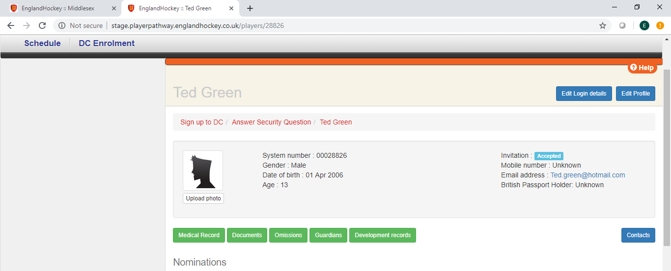
Click on the green ‘omissions’ button on your profile page.

Your omissions

This is where you can post on the system when you are unavailable to attend events e.g. you
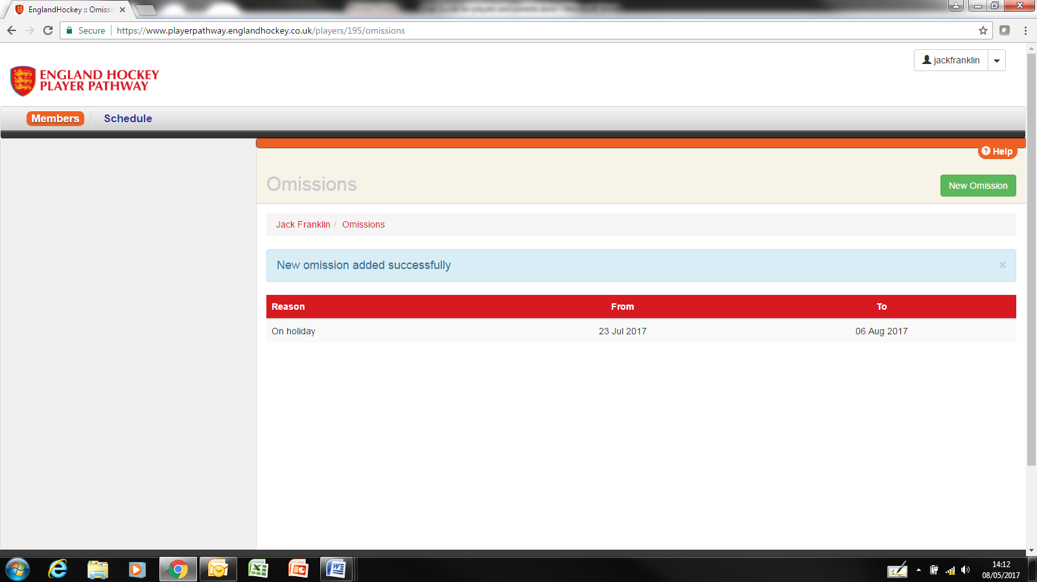
New Omission
To add a new omission click on the New Omission button.
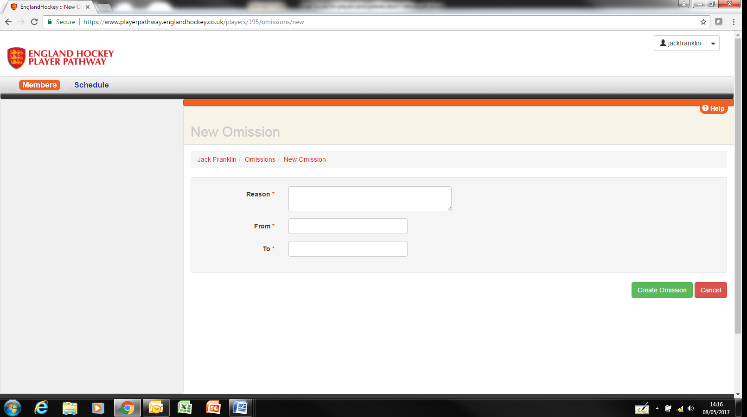
Enter the reason for your absence and then the ‘from’ and ‘to’ dates. Save the information by clicking on the Create Omission button.
If the coach tries to select you for a match or training on these dates you will be shown as unavailable.

To update or delete an omission click on the required omission on the list.
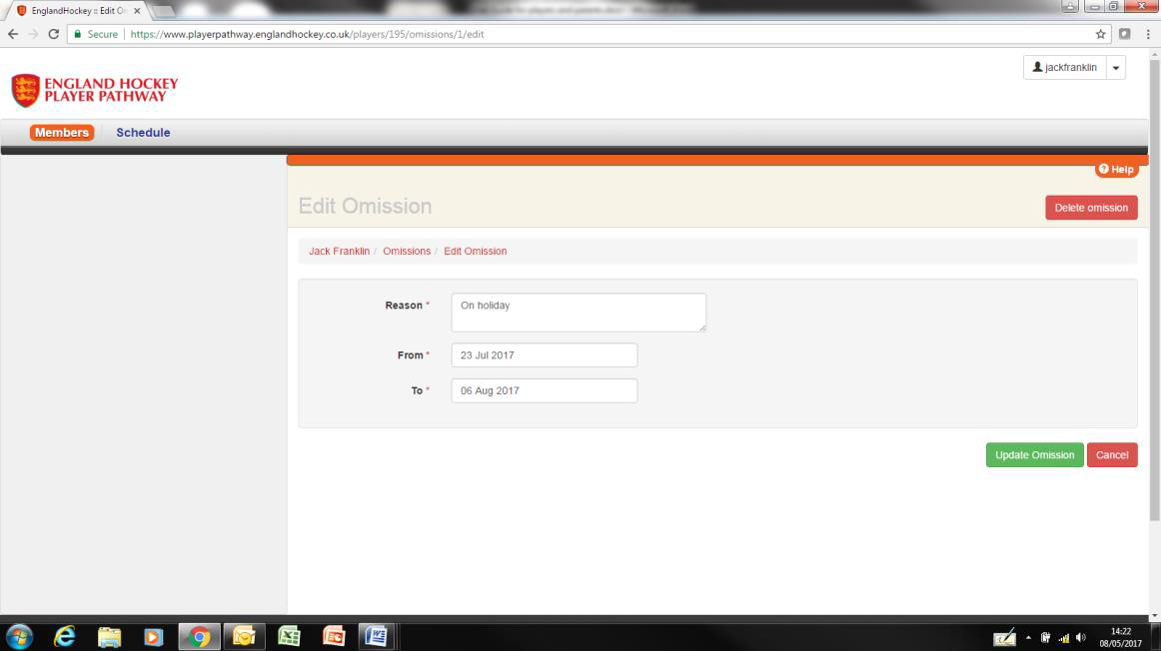

Change the details as required and then click on the Update Omission button to save them.

To delete an omission, click on the Delete omission button and confirm.

