v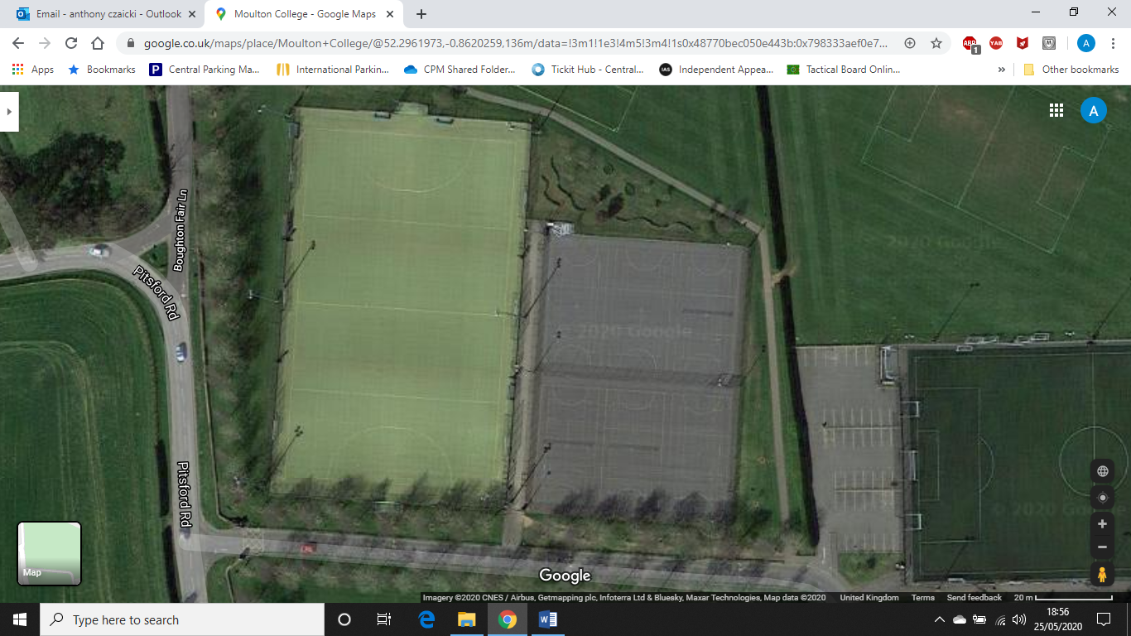

Do Not Use This Car Park.

Entrance to pitches.

Please only use the correct gate for your coach/pitch

Pitch 3

Pitch 2

Pitch 1

Exit Routes ONLY