**Advice for Participants**

This summary is aimed at helping individuals understand their responsibilities as a participant when getting back on a hockey pitch safely. Max Wilkinson is the NHC Covid officer. If you have ANY queries please contact him. 07504279874

When playing away at other teams please ensure you follow any guidelines provided by the opposition. Our processes are specific to our club. If in doubt please contact the Covid officer.

**Preparing to play**

Participation Agreement – Anyone wanting to be involved in hockey must sign an England Hockey Participation Agreement before they play (this only needs to be done once). Junior players will need a parent/guardian to submit on their behalf

For both training and matches you will receive a selection email via clubuzz. You must respond to this ASAP. For training coaches will message to confirm group allocation and meeting time. Captain or coach will confirm meet time for matches.

The maximum group size involved in one group of close contact is 30, including coaches – coaches will allocate groups. For training the pitch will be divided into two at the halfway line to enable two groups to train. Note for matches umpires are included in the group of 30 on pitch.

On day of training/match a self-assessment check must be completed. Coach/captain will contact you via whats-app with a checklist of symptoms. You must confirm you are symptom free or have any other reason to isolate before travelling to the pitch.

Spectators will not be allowed. This will be reviewed once training/match day procedures have been operated. For any exceptional cases please contact Max Wilkinson for guidance.

**Equipment**

Use your own equipment – sticks, gumshields, facemasks (if required), goalkeeping equipment (if appropriate) and ensure water bottles are full on arrival. Please mark/label water bottles as required to ensure they are easy to identify.

**Travel**

All coaches and participants advised to travel individually. Avoid use of public transport if possible. If lift sharing is only option, ensure travelling group is the same each week and players should wear masks, with windows open in cars and the car should be cleaned after each journeys using standard cleaning products - make sure you clean door handles and other areas that people may touch.

**Arrival at pitch**

Arrive as close as possible to your designated time and check in with coach/captain, to ensure track and trace requirements are met.

Your coach/captain will direct you to relevant holding area for your group (ref pitch map). You must wait in holding area until others have left the pitch. Please ensure you understand the entry and exit routes (ref pitch map)

Arrive changed and ready to play. Bring minimal kit to pitch side – ideally just stick, protective equipment and water bottle.

Clean hands using sanitizer (sanitization station will be available)

While waiting maintain distance to other members of your group.

Before moving into the pitch your coach or captain will give a quick briefing to remind you of the COVID-19 guidelines.

Once pitch has been cleared your coach/captain will let you know to move to your group’s area on pitch. Maintain distance while moving onto pitch.

**During play**

Respect your opposition and umpires.

Take Penalty Corners and free hits around the D promptly.

Touch the ball with your stick/GK equipment and not your hands.

If you are doing a passing drill only touch any of the balls with your stick.

Use your own protective equipment or disinfect before use (e.g. facemasks).

Socially distance when play stops. Do not share drinks/refreshments during breaks in play. Avoid regular removal of your gum shield.

Avoid shouting excessively or spitting.

No handshakes with other players or close contact during goal celebrations.

Where possible, unless absolutely necessary, avoid touching gates/fences/goals.

During matches substitutes and coaches must be away from playing area (ref pitch map) maintaining social distancing while there.

**After play**

Collect all of your kit and any rubbish (e.g. empty drink containers), and when instructed by your coach or captain leave the pitch area via the correct exit route.

Use hand sanitizer on exit from the pitch

If you show symptoms of Covid-19 you should phone NHS Track and Trace and let your club/ organisation Covid Officer know immediately. You should also contact anyone you have been in contact with during one of your sessions in the past 48 hours.

If you show symptoms during the session you must advise coach and leave the session immediately and follow NHS guidelines. Covid officer should be notified for follow up with NHS track and trace.

**Site plan for water based pitch (Gate 4):**

Dugouts are not to be used by any players.

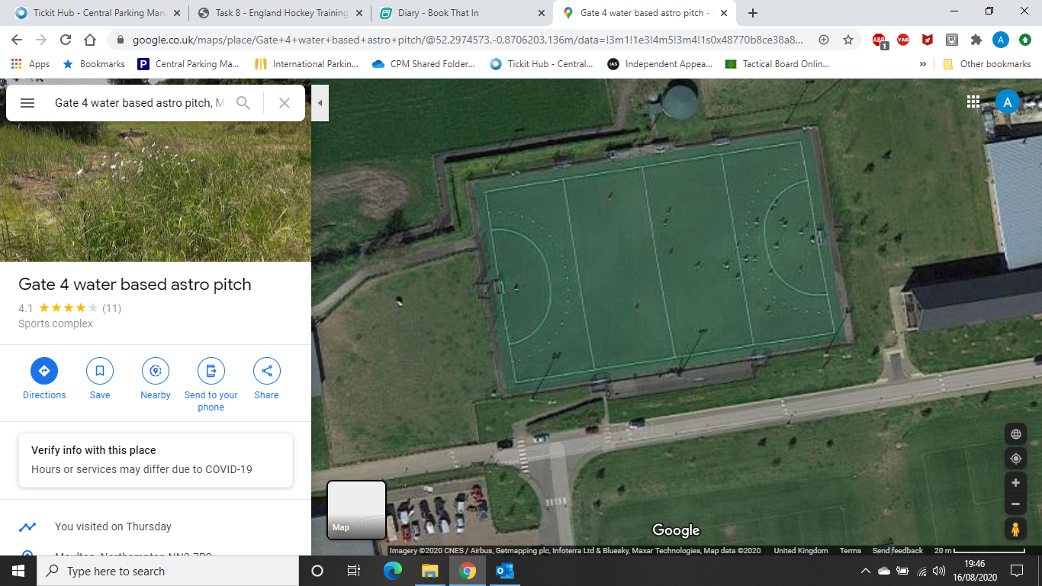

The pen is Strictly for use during matches for substitutes and coaches. If people are in here, they MUST socially distance 2m away from other households and people’s possessions.

Players are to only bring ESSENTIAL items (playing equipment and drinks bottle) on to the pitch, and may leave them on the side of the pitch.

There will be a sanitiser dispenser at the entrance to be placed by the college. This MUST be used on entrance AND exit of the pitch.

Games are to be booked in no less than 1 and a half hour slots to ensure players can leave the pitch without contact with other teams.

If using the pitch on multiple occasions, the participants MUST go to the sanitation station near the entrance and cleanse.

Designated Waiting Areas

Route Off the pitch. 

Route on to the pitch 

Toilets are provided at Both sites but no other building can be entered at any time**.**

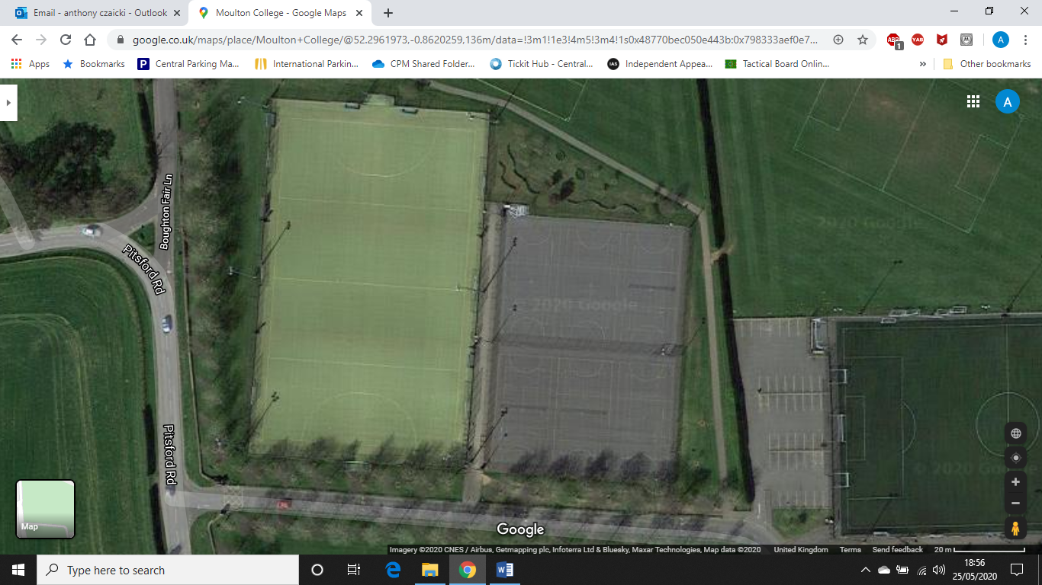**Site plan for Sand based (gate 3):**

Pitch 3

Exit Routes ONLY

Pitch 2

Pitch 1

Do Not Use This Car Park.

Designated Waiting Areas

Entrance to pitches.

Please only use the correct gate for your coach/pitch