**Advice for Coaches**

This summary is aimed at helping coaches understand their responsibilities as a coach when getting back on a hockey pitch safely.

**General**

Max Wilkinson is the NHC Covid officer. If you have ANY queries please contact him. 07504279874

Coaches must sign an England Hockey Participation Agreement before delivering any activity (this only needs to be done once), where they agree to the terms and conditions and Code of Ethics and Behaviours. They can sign up here.

Coaches must understand all the expectations placed upon players and play a role ensuring that protocols are followed.

The maximum group size (including coaches) is 30 for competitive training or match play. More than one group of 30 can use a pitch but must remain separate from the other group.

Coaches (that remain socially distanced) can move between groups. Small group coaching sessions continue to be allowed and we strongly recommend that parents / carers should be present for sessions involving young people at this time. This is mandatory for one to one coaching sessions.

Parents should always remain in sight of young players whilst maintaining social distancing.

When playing away at other teams please ensure you follow any guidelines provided by the opposition. Our processes are specific to our club. If in doubt please contact the Covid officer.

**Facilities**

Teams MUST wait in the designated area and ONLY enter the pitch when advised to do so.

Players must maintain social distancing rules in these areas.

Below are the details for player movement on the Water Base

**Site plan for water based pitch (Gate 4):**

Dugouts are not to be used by any players.

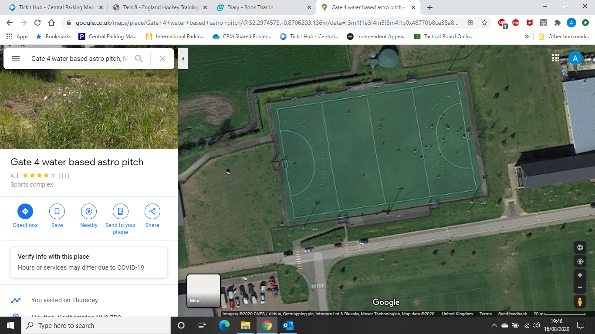

The pen is Strictly for use during matches for substitutes and coaches. If people are in here, they MUST socially distance 2m away from other households and people’s possessions.

Players are to only bring ESSENTIAL items (playing equipment and drinks bottle) on to the pitch, and may leave them on the side of the pitch.

There will be a sanitiser dispenser at the entrance to be placed by the college. This MUST be used on entrance AND exit of the pitch.

Games are to be booked in no less than 1 and a half hour slots to ensure players can leave the pitch without contact with other teams.

If using the pitch on multiple occasions, the participants MUST go to the sanitation station near the entrance and cleanse.

Designated Waiting Areas

Route Off the pitch. 

Route on to the pitch 

Toilets are provided at Both sites but no other building can be entered at any time**.**

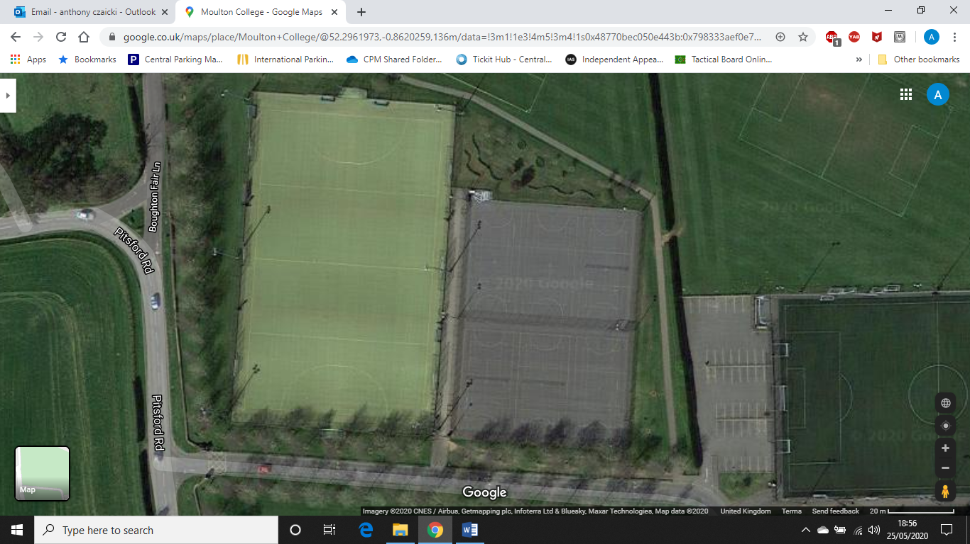**Site plan for Sand based (gate 3)**

Pitch 3

Exit Routes ONLY

Pitch 2

Pitch 1

Do Not Use This Car Park.

Designated Waiting Areas

Entrance to pitches.

Please only use the correct gate for your coach/pitch

**Preparation**

Coaches should take all reasonable steps to ensure that sessions are as safe as possible.

Coaches must use club buzz to confirm the register of all attendees to ensure any track and trace requirements can be easily fulfilled. This must be shared with the Covid Officer.

It is a Coaches responsibility to brief each Bubble of the regulations and standards that they should be adhering too.

The coach will need to gain confirmation from each player that they have self-diagnosed on the day of each training session and match. A pre-formatted self-assessment question list will be provided, and coaches will message their group using a whats-app message to obtain the confirmation from all participants. No participant is allowed to join their group until they have confirmed self-assessment.

Think about how you divide the pitch if more than one group is using it to ensure there is sufficient space between groups. The aim should be to ensure groups have significant space at all times including at the start and end of sessions.

Groups should not mix but coaches can move across groups.

Social distancing, to a distance of at least 2m, must be maintained outside of competitive training or matches.

Coaches should adapt sessions accordingly following England Hockey guidance.

Coaches should avoid delivering training exercises that involve overly repetitive close contact between players.

There is an additional risk of infection in close proximity situations where people are shouting or conversing loudly. This particularly applies indoors and when face to face. If possible, players and coaches should therefore avoid shouting or raising their voices when facing each other during, before and after games.

**Equipment**

Players will bring their own personal equipment (sticks and personal protective equipment).

Fresh balls and sticks should be used for each session – balls and sticks should be stored separately after use and disinfected or stored for at least 72 hours before being used again.

Coaches should collect balls, or the player return them with their stick/feet, not hands. Balls will be disinfected after use.

No contact between player and other coaching equipment – it is recommended that limited equipment is used if possible. Use other coaches to assist with goal movement – ideally set-up ahead of session

**First Aid**

Suitable first aid supplies will be provided – coaches to ensure they have kit available for use. If kit is not available or replenishment is required contact club captains.

For minor injury player should self treat using supplies, disposing of any used supplies themselves.

If injured player requires support (e.g. junior player) member of household should attend if possible.

If household member is not available coach should attend, ideally using suitable ppe (facemask, gloves) while in close proximity to injured player.

**Further notes**

Coaches should regularly remind participants (and parents/guardians where appropriate) of the expectations and standards required.

Coaches should ensure that the venue has the necessary standards in place before, during and after the activity before deciding to use the venue.

When communicating with players, avoid regular removal of gum shields

If you show symptoms of Covid-19 you should phone NHS Track and Trace and let your club/ organisation Covid Officer know immediately. You should also contact anyone you have been in contact with during one of your sessions in the past 48 hours.

If any players show symptoms during the session the players should be instructed to leave the session immediately and instructed to follow NHS guidelines. Covid officer should be notified for follow up with NHS track and trace.

**Walkthrough:**

**Before Training/Matches:**

Ensure all Players have signed the Covid Participation form

Use clubbuzz ‘selection list’ to create groups for training and contact groups with their training group and meeting time

On the day contact groups to obtain self-assessment confirmations

**Travelling:**

All coaches and participants advised to travel individually. Avoid use of public transport if possible. If lift sharing is only option, ensure travelling group is the same each week and players should wear masks, with windows open in cars and the car should be cleaned after each journeys using standard cleaning products - make sure you clean door handles and other areas that people may touch.

**Arrival at pitch:**

Clean hands using sanitization station (or personal and sanitizer) on arrival

Open gates and clean contact points using sanitizer

Prepare pitch areas and organise equipment (goals, markers, balls) ready for sessions

Meet players and direct them to relevant holding area ensuring players have confirmed self-assessment and ensure they use hand sanitizer ahead of moving into the pitch area

Keep players at a social distance at all times

While waiting for previous users to leave the pitch, the new group must be briefed on the responsibilities and expectations. Use the EH infographic as a guide for this – highlighting key points.

Confirm pitch is fully cleared ahead of instructing relevant group to move to their designated area on pitch.  
**During Training:**

Keep players at a social distance when not in a competitive environment

There will be 3 crates of balls per training session. Tuesdays, Thursdays and Junior on Saturdays. There will be 1 crate of balls per area.

Players should collect balls with their feet or stick NOT HANDS. They should only select balls from their pitch space, balls that cross areas will have to be returned by coaches, or players in that are (with feet or stick).

**After Training:**

Ask players to collect their own kit and promptly leave the pitch via the correct exit, maintaining distance during exit. Advise players to use hand sanitizer on exit. Ensure players take their own rubbish (e.g. empty drink container etc.)

Only the coach should collect balls and other coaching equipment. Balls must be disinfected prior returning to crates ready for storage.

Clean and return equipment to designated area

Leave pitch taking personal equipment and/or rubbish.

Close gates and use sanitizer to clean handles after these have been closed

Use hand sanitizer to clean their hands

Update club buzz to confirm attendees and confirm update Max Wilkinson ASAP (Note Max must submit complete register within 24 hours of session/match being completed.