Captain / Managers Guide for using Teamo
Members should complete the re-registration process on the website to join the club for another season.
Full instructions are in the automated email. If they no longer wish to be part of the club, they need to click on the appropriate link.
Members will then be directed to sign up to Teamo – this will be used for collecting fees, recording availability, selection and communication.
All returning and new members should complete the registration process including which Membership Option they require.

How to join TBB on Teamo
Simply use the link below to join TBB
https://www.teamo.chat/club/register/tbbhc1

Payments
Payment for membership and fees will be assigned via Teamo using GoCardless.
Requested membership products will be assigned (around 1 Oct) and members will then be able to pay. Note: The default will be for payment by installments unless as single payment is requested.
The first-time members pay, they simply need to head to Settings > My Payments and choose to pay by GoCardless. They will then be sent to GoCardless to set up their Direct Debit with the club. Once complete, members will be sent a confirmation email and able to complete the payment. If they already have a GoCardless account, they can link this to the app for payment.
Players can then view their payment history and any payments due by going to Settings and clicking on the Credit Card icon (top right)

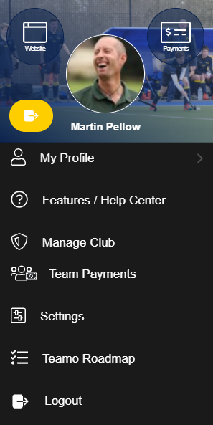
Reviewing Paid Status
Captains and Managers can see the status of any payments of their squad via the ‘Team Payments’ section. This can be accessed from the ‘Settings’ Menu (top left) in the app.
Simply choose your team from the club list.
If a player has not paid, they should not be selected!
Teamo allows you to send a quick prompt reminder to players who have not paid their fees.
The paid status of players selected will be checked by the Club Captains and Director of Club Hockey.

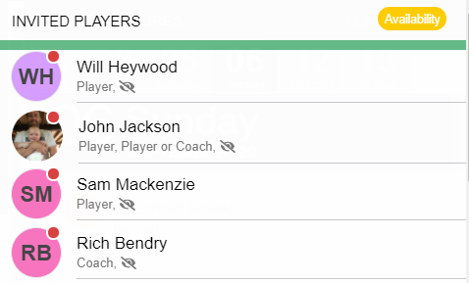
Captains and managers can easily see if a player has paid or not via the dot on their profile picture.
Red dot = not paid/pending
Green dot = paid
Please note that the dot will remain red even if the payment is pending and will only go green once payment is received.

Match Fees
Captains and Managers can also allocate a match fee to a player. This would apply for any players on the ‘Training Only’ membership or Guest players for Masters games.
Match fees can be assigned once the event has passed and you have confirmed your team.
You can also edit a match fee if a player did not play a whole game or was injured.
To edit a player’s match fee, go to Settings > Team Payments and select your team and the match you would like to edit a payment for. Select Edit invoice

Squad Manager
This is a desktop only feature. https://web2.teamo.chat
Head to Settings > Manage Club > Member Centre and select Squad Manager from menu on the right side
Squad manager gives an overview of the club and allows you to drag and drop players into different teams.
To avoid confusion, parents/guardians will not show in Squad Manager.
You can move players into multiple teams if they are a regular payer in two squads. If players are required to move up or down a team on an ad-hoc basis, team captains can easily invite players from another squad to their fixture, so it is not necessary to place them in both squads.
Players can be members in as many squads as needed. You can choose to ‘copy’ the player to add them to a new squad while they remain in the old one. Or ‘move’ the player from one squad to another.
To move a player out of a team, click on their name and drag them down to the bin icon, located on the bottom right hand side of the screen.

Adding officials to your team/fixture
Teamo allows you to add officials (umpires/coaches) to your squad. This is important for Trace and Trace purposes.
Select the fixture and then ‘Manage’. Click on the ‘Add’ icon in the top right corner. Search for the person you want to add to the squad/fixture and press ‘Add’
This will add them to the ‘Squad List’. Click on their name and the ‘options’ menu will appear. Select ‘Edit Event Role’ and choose ‘Official (non-player)’. This will then add them to the fixture. They will appear at the bottom of the team list.
After the fixture you can ‘Uninvite’ them from the squad.

Team Email
Teamo has the feature to email your team (or whole club/section – Admins only) in one go with the team’s unique email address.
Simply enter the unique team email into the To: field from your email account and this will send a message to all members in the team. Members of your team can also reply to the email if they wish.
To view your team’s unique email address simply go to Contacts > Teams and Select Your Team. In the Team Messaging Options you will find the team email address. You can email directly from the app or copy and paste.

Track Player Attendance /Play Safe
Player attendance at training sessions will be automatically updated via the Play Safe feature on Teamo which requires all players to ‘sign in’ for their sessions including matches. Please see the guidance for Captains, manager, and coaches on this on the website:
http://www.teambathbuccaneers.co.uk/returning_to_competitive_play
ALL PLAYERS MUST UPDATE THEIR AVAILABILTY FOR TRAINING PRIOR TO SESSIONS. IF THEY DO NOT MARK AS AVAILABLE THEN THEY WILL NOT BE ABLE TO ATTEND THE SESSION. SPACES ARE RESTRICTED.
This is easily done by going onto the relevant session on the calendar in the Teamo app and updating availability.
Captains and managers can also add attendance manually.
To view Attendance Registers, head to the training event via Calendar. Tap Mark Attendance under the Coaches/Managers Summary, then select Attendance Register
You can get an overview for all training sessions by heading to Contacts > Teams. Select your team > Attendance Report.

Recording season Stats
For a game, you can record goals, assists, cards, player of the match and add a match report.
To add match stats, go to Calendar and select the fixture. Select Edit and the Add Statistics
You can choose to post match reports and this will then be linked to our Facebook account.
Captains and Managers can view selection stats for every player including availability as well as a % of total games each player was selected for.
To find the season overview, head to Contacts > Teams (tab at top). Select your team > Season Statistics.
This can also be downloaded/printed

How to view upcoming fixtures
A summary of all the club fixtures can be viewed by selecting ‘the club' icon from the app dash board.
All events can be viewed via ‘Calendar’

Editing Fixtures
You can edit the details of any fixture for example to add match day information. Select the fixture and then ‘edit’
Please make sure that the match venue is registered on the ‘Play Safe’ list.
If you want your players to confirm after they have been selected for a fixture, make sure this feature is switched on in the ‘Advanced’ section.

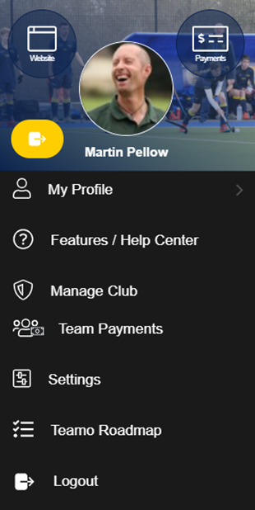
Feature and Help Centre
For more information about the different feature of the App the Feature / Help Centre is useful. You can also access video guides.
This can be accessed from the Settings menu.

