Tibberton Netball Club
COVID 19 Information – Elite Trials 2021
Idsall Sports Centre, Outdoor Courts

This document aims to outline the measures put in place to allow us to train safely, there is further information and links to the relevant England Netball Covid pages and documents on our club website.
https://tibbertonnetballclub.clubbuzz.co.uk/members/covid_19

General Information:
Whilst comprehensive measures have been put in place to reduce the risk of transmission, there is an increased risk associated with taking part in the sport of netball. If you have underlying health conditions and are considered clinically extremely vulnerable or moderately vulnerable, there is an increased risk in taking part in netball activity.
Please read the personal risk assessment document on our website in full.
Pressure will not be placed on players to participate if they are uncomfortable with the risks associated with netball activity; you may defer your trial place, please confirm via email to tibbertonnetballtrials@outlook.com .

Before training:
- Pre activity Health Screening – all players should check themselves and anyone else in their household before leaving for a netball activity. If you or anyone else in your household has symptoms, you should not attend netball. The covid symptom checker can be downloaded on our website.
- Kit, Sanitisation and Equipment – All players should come dressed ready to play, changing facilities will not be available. Hands and personal equipment or items should be sanitised before leaving for netball. Any personal items such as water bottles and kit should be clearly marked.
- Travel to Venues – The Government are continuing to issue advice on the safest way to travel, the latest Government advice can be found here.
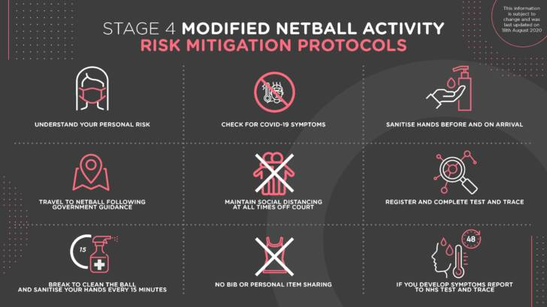
On arrival:
- Entry - All players must enter Idsall Sports Centre via the main path, to the right of the buildings. Players will be asked to queue outside the gates to the courts at 2m intervals until called forward to the registration desk.
- Parents/ Guardians and spectators are allowed to watch from outside the court netting. Please observe social distancing guidelines, and you may be asked to move to another area if there are more than 30 people. For Safeguarding purposes, Junior players should be accompanied to the gate to the courts, where they will be met by a club official.
- Upon entering the venue all players should remain 2m apart at all times during registration and whilst moving around the venue.
- All players will be asked to verbally confirm that they have complied with the health screening document, and they will be registered by a club official at the registration desk.
- We will have a QR code available on the registration desk, and around the venue which may be scanned by parents / guardians if they so wish. But as we ask Junior players to leave their phones at home for netball sessions we will be using the paper registers to comply with the Test and Trace protocols.
- Players will be asked to sanitise their hands before entering the courts.

During training:
- Sanitisation and Equipment – All players are required to sanitise their hands every 15 minutes during the session. We will be providing hand sanitiser, but you are welcome to bring your own bottles; as this will help to speed up the process.
- All balls and equipment used will be sanitised every 15 minutes – there will be bags/areas clearly marked as ‘clean’ and ‘dirty’ so please make sure that you put the equipment in the correct area after use. We will require extra help from parent volunteers for this – if you are able to help please let us know.
- Bibs should not be shared – all bibs will be washed after every session, players may be asked to turn their bibs inside out if they swap positions during a match in training.
- Water bottles and Whistles must not be shared.
- Social Distancing – wherever possible, social distancing will be incorporated into warm up activities and small sided games. During the drinks breaks or ‘idle interactions’ in training players are expected to maintain their 2m.
- Team talks will remain socially distant - there will be no team huddles, ‘hands in’or high fives.
- Rule Modifications – there have been a number of the normal netball rules modified to allow for a safer game. A simplified summary can be seen below. Further information can be found on the England Netball website (via link on our club website) – and will be taught in sessions by our Coaching Team.
- Covid Symptoms – if a player develops Covid symptoms during a session, they will be removed from the courts and accompanied to a quarantine area by the first aider present. The first aider will remain with the player, and will wear appropriate PPE. We will call the contact details on the player registration form and ask you to collect the player as soon as possible.
- Toilets –the toilet area is ‘one in- one out’; and Players will only be allowed to exit the courts to use the toilets one at a time. Please make sure that players have used the toilets before leaving home to help us to minimise the need to use the facilities in the sports centre. All members over the age of 11 are required to wear masks if they wish to use the toilets. Obviously, we do not want used masks to be left lying on the floor for contamination reasons, so please ensure that all players bring a suitable bag with them.

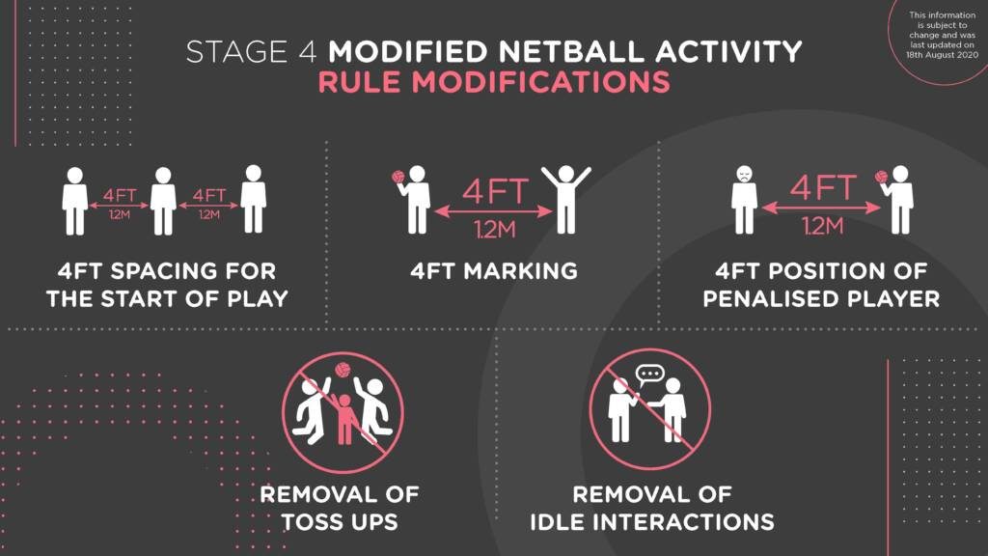
After training:
- At the end of the session all players should leave the court straight away and leave the venue promptly via the main gate.
- A club official will oversee the Junior players leaving to ensure that they are met by a responsible adult for Safeguarding purposes, they will not be allowed to walk to the car park alone.
- All players will be asked to sanitise their hands at the end of the session.
- If any attendee develops Covid symptoms up to 48hrs after any netball activity, please follow NHS advice, and notify the clubs Covid Officer via the below email address if the test is positive- tibbertonclubmanager@outlook.com.
- Details of how we will deal with a positive test within in the club can be found on the club website.

