**MIDLANDS AC COMPETITIONS**

**U13 Boys Finals**

**SUNDAY 13th March 2022**

**HOST:** Northamptonshire  
**VENUE:** Water based Pitch, Gate 4, OR Sand Based Pitch, Gate 3, Moulton College, Pitsford Rd, Moulton, Northampton, NN3 7QL

**ATTENDEES:** Boys: Northants x2, East Warks x2, West Warks x2, Derbs x2, Leics x1 (9 teams)

U13 Boys WATER BASED PITCH GATE 4 – 15 Minute Games, 7 minute turn around

|  |  |  |  |
| --- | --- | --- | --- |
| **START TIME** | **Team Off** | **Pitch 1 Water based** | **Pitch 2 Water based** |
| **10:00** | Leics | Northants 1 v Derbs 1 | East Warks 1 v West Warks 1 |
| **10:22** | East Warks 1 | Northants 1 v Leics 1 | Derbs 1 v West Warks 1 |
| **10:44** | Derbs 1 | Leics 1v East Warks 1 | Northants 1 v West Warks 1 |
| **11:06** | Northants 1 | West Warks 1 v Leics 1 | Derbs 1 vs East Warks 1 |
| **11:28** | West Warks 1 | Leics 1 v Derbs 1 | East Warks 1 v Northants 1 |

U13 Boys SAND BASED PITCH GATE 3 – 20 Minute games, 2x 10 min halves, 3 mins half time and 7 mins turn arounds.

|  |  |  |
| --- | --- | --- |
| **START TIME** | **Pitch1 Sand Based** | **Pitch 2 Sand Based** |
| **10:00** | Northants 2 v Derbs 2 | East Warks 2 v West Warks 2 |
| **10:30** | East Warks 2 vs Northants 2 | Derbs 2 v West Warks 2 |
| **11:00** | Northants 2 v West Warks 2 | Derbs 2 v East Warks 2 |

Games to start promptly regardless of stoppages.

* Note that umpires will keep to the finish time regardless of start times, adjusting game duration, because there are further pitch bookings at 12.00pm. Can team managers please be made aware of this and not complain to the umpires when the games are shortened.
* Pitch A Games will be 15 Minute Games, 3 minute turn around. Pitch B games will be 20 Minute games, 2x 10 min halves, 3 mins half time and 5 mins turn arounds.
* Umpires will be supplied.
* Games to be played to the current FIH rules of Hockey.
* First named team will provide the match balls.
* Dogs are not allowed on site.
* Bins are provided and attendees are asked to place rubbish in them.
* Refreshments are available at the bar and/or cafeteria.

**HOSTING COUNTY CONTACT DETAILS:   
Coordinator:** Anthony Czaicki **Email:** antczaicki@hotmail.co.uk **Mobile:** 07712704721

**U13 Boys Contact:  
Coach:** Anthony Czaicki **Email:** antczaicki@hotmail.co.uk **Mobile:** 07712704721

Pitch A – Water based

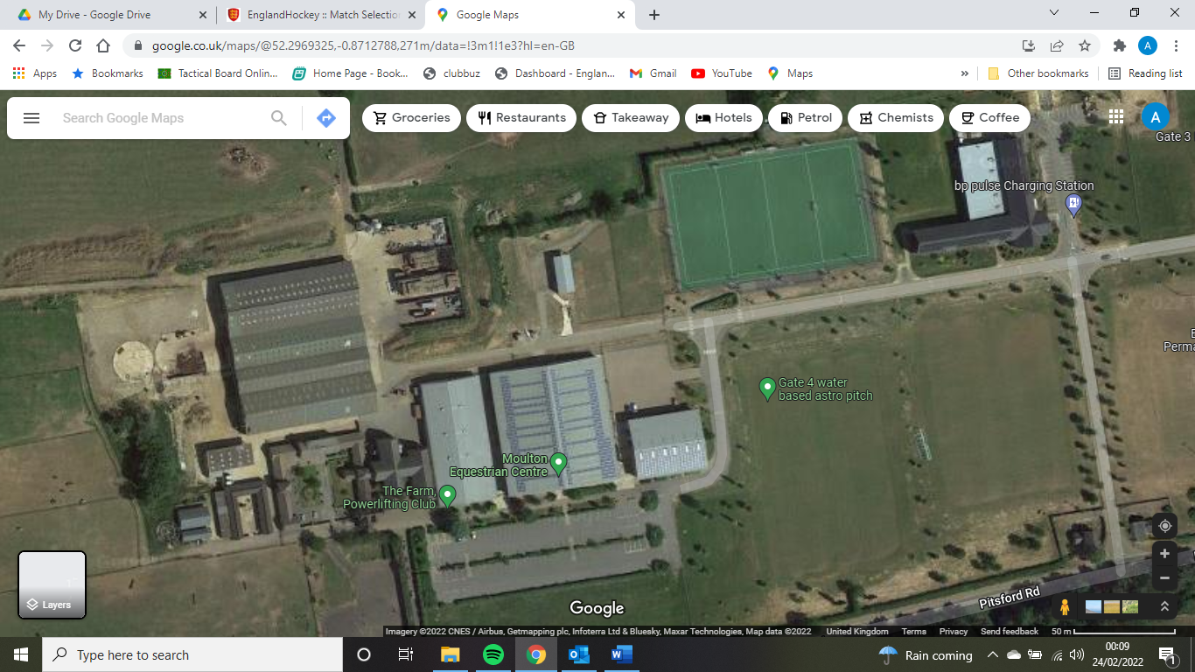

Parking

Entrance

Pitch

Café/toilets

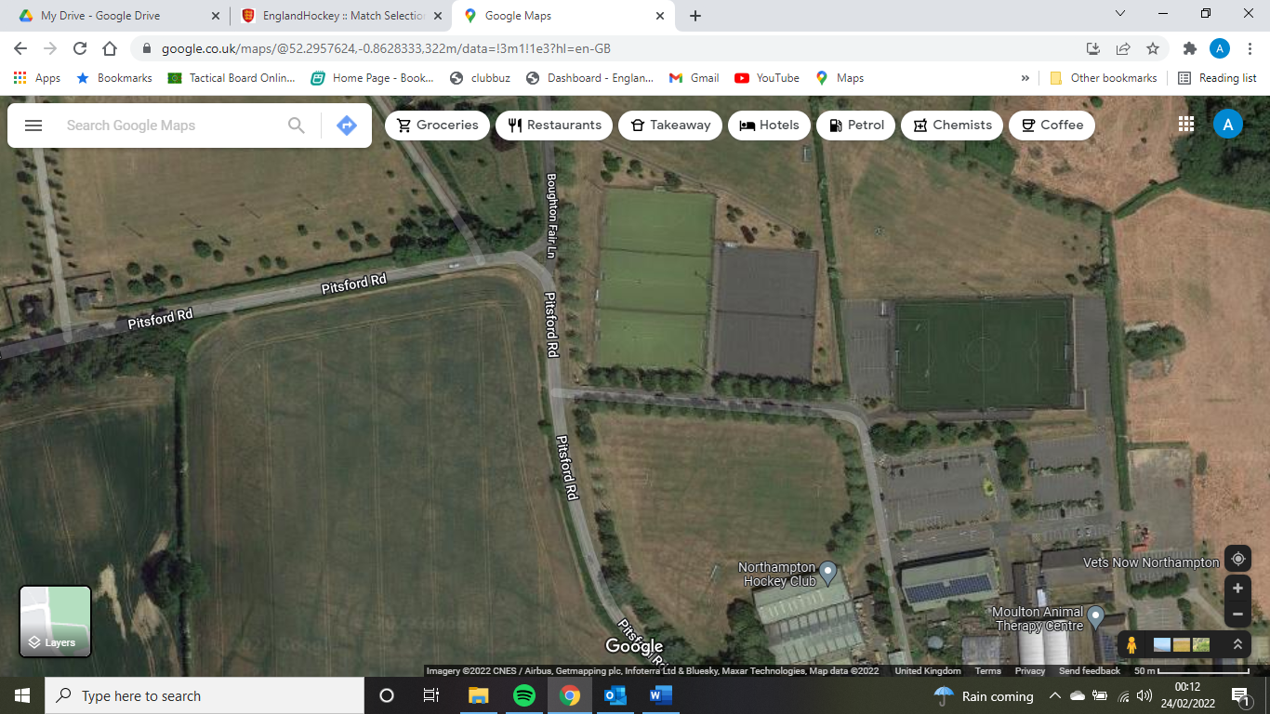Pitch B – Sand Based

Toilets

Parking

Entrance

Pitch