We would like to thank all below for their support:

The Catering/Bar and STV Staff from the University of Bath



**Bath Mixed Hockey Festival**

**16th & 17th August 2014**

**University of Bath**



**Notes**

**Welcome to the Bath Mixed Hockey Festival 2014**

A very warm welcome to you to the 13th annual Bath Mixed Hockey Festival. Whether this is your first year or you've been with us from the start we very much hope that you enjoy what should be a great weekend.

This year we have we will play in 7-a-side format introduced successfully last year. All matches will be on Astroturf with pool games on Saturday and on Sunday, teams will be split between Cup, Plate and Trophy competitions based on your performance or non-performance. Trophies will then be awarded to the winners of each competition. Please try to stick around on the Sunday after your final game as your team may be in the running for the prestigious 'Team of the Festival' award.

All of the pitch side activities, including the Control Marquee, Disco Tent, BBQ/Beer tent, are all alongside the Astroturf pitches. Access to the festival site is through the Sports Training Village Centre Reception.

The Friday social including Disco will be held at the Parade Bar on campus (open all day until 2am) so it’s only a short stagger to your accommodation after your day of travelling.

The Saturday night bash will be held off campus at the Second Bridge Night Club, 10 Manvers Street BA11JQ. Meet in the Earl Bar next door as entry to the club is from 22:30. Fancy dress is Roaring Twenties or smart casual as the club has a dress code. Buses (journey time only 5 minutes) will run between the University bus stop and the City Centre every 10 minutes until late.

On Saturday morning at 9.30am all captains need to register their teams at the Control Marquee. Captains will then be given their registration pack containing 10 free wrist bands, for night club entry, match schedule and programme. Any extra numbers for the night club can pay on the door £5.00.

We know that it is easy to forget but can each team please make sure that they leave an umpire/able body for the next game and the first named team to advise the Control Table of the match score to help with the smooth running of the festival. Please bring your own whistle.

All games will be centrally timed and announced on the speaker system.

**Have a great time!**

**Festival Playing Rules**

1. Games will be 7-a-Side format with 15 minutes one way, centrally timed with a blast from the hooter.

2 Maximum no per squad per match is 10

3 Use of goalkeeper optional

4 Substitutions at any time from the half way line only..

5. Each team to provide an umpire/body on the pitch to umpire the game after.

6. First named team provides match ball, has choice of ends and takes push back.

7. Second named team to change colours if required.

8. Ladies strike on short corners. Otherwise mini hockey rules apply.

9 First named team to advise theControl Tent of the match score.

10 Minimum of 3 ladies on the pitch at any time.

11. Points: Win - 4 points, Draw – 2 points, 1 point for playing the game.

12 Where teams level on points placing will determined by

- Goal difference

- Goals scored

- Goals conceded

- Result or relevant match

- Coin toss

12. Festival organised into a Cup, Plate and Trophy for Sundays schedule.

13. Pitches A1 and B2 are on the Sitec Waterbased Pitch & C3 and D4 on the Sand Dressed Pitch

14 Organisers decisions final



**Saturday Fixtures**





**Notices**

* The Festival beer tent bar is operated on a commercial basis and managed by University Catering Services with some profit going to the club. We would appreciate your support by only consuming alcoholic beverages purchased from the Festival beer tent bar. Thank you.
* We would also ask that teams are respectful to other residents of the campus. Please try to keep any unnecessary noise and harassment to a minimum. Any issues reported to the University may jeopardise future festivals!
* Please use the toilets located in the STV and not on the pitches !
* Please note a TOKEN system will be operating for food and drink. Tokens are available at the Control Marquee.

Orchard Studio will be providing a range of hip-hop, chill-out and retro tunes throughout the day.

**Programme**

**Friday (Afternoon – 2am)**

* Drinking, music & dancing with the Orchard Studio Disco in the Parade Bar on campus (see map). The Parade Bar is open all day so a good excuse to turn up early! Music from 8.00pm till 1.00am. A full menu will be provided in the Parade Bar until 6pm. Between 6pm and 9pm Bar food available.
* Please note the Parade Bar is the only place on campus serving food in the evening and no food will be available after 9pm.

**Saturday (9.30am – 1am)**

* BBQ opens 9.30am serving bacon rolls and burgers
* Matches start at 10:20am on Saturday
* Festival beer tent opens 11am
* The last matches finish at 4:20 pm
* Playing schedules for the Cup, Plate and Trophy on Sunday will be announced on Saturday night.
* Evening entertainment at the Second Bridge Night Club from 22:30 – 02am, following the usual successful format of disco, fancy dress Roaring Twenties (optional but smart casual if not), bad dancing and possibly some drinking. Your wristband is your ticket.. Suggest meet next door at the Earl Bar from 20:00.

**Sunday (10.30am – 5pm)**

* BBQ starts 10.00am serving bacon rolls and burgers
* Matches start 11.00am
* Festival beer tent opens 11am
* Finals finish at 4pm
* The Awards ceremony and sadly depart for the journey home.

**Control Marquee**

The control marquee is the focal point for all festival queries, information, announcements and advice. Please note:

* All results must be communicated by the first named teams to the Control Marquee following each game.
* Tokens for food/drink can be purchased from the Control Marquee.
* Festival Registration is at 9.30am Saturday morning.
* First Aid will be provided by the staff of the Sports Training Village but basic First Aid equipment is available at the Control Marquee for individual use.
* Please notify the Control Marquee of any serious injuries.
* Any lost property should be handed to and claimed from the Control

Marquee. Please ensure that you secure your valuables!

* Announcements are done from the Control Marquee. Any urgent announcements can be arranged on request.
* Purchase of raffle tickets.

**Prizes**

* Limited Edition beer/nasty jugs will be awarded to the winners of the Cup, Plate and Trophy Finals.
* The Team of the Festival award is also up for grabs (all teams are automatically entered for this) and the winner will be judged on their playing attitude (not necessarily skill!), festival spirit, sportsmanship and contribution to the weekend!

**Photos**

**If you are taking photos’ in the STV/pitch area, during the weekend ,please register at Reception on arrival on Saturday**

If you have any interesting photos taken during the weekend that you would like published then please send to: [ndk20@bath.ac.uk](mailto:ndk20@bath.ac.uk)

Selected photos will be published on

[www.teambathbuccaneers.co.uk](http://www.teambathbuccaneers.co.uk)

[www.teambath.com](http://www.teambath.com)

TBB Facebook

@TBBhockey

**Transport Information**

**Buses Into Bath**

Buses (no U18) into Bath city centre runs every 10 minutes from the Bus Terminal and takes only 5 minutes and costs approximately £1.20. You can catch the bus on campus at the bus stop as indicated on the map.

**Taxi**

A number of taxi companies are available in Bath for transport into or back from the city. Try the following:

Abbey V-Cars:

South Parade Cheltenham St

BA2 4AF BA2 3EX

01225 444444 01225 464646

**First Aid**

First Aid is available at two points on the festival site as below:

* The Control Marquee will hold basic First Aid supplies such as plasters and ice packs for minor injuries.
* The Sports Training Village Duty Manager’s Office holds full First Aid equipment and has qualified First Aiders available.
* If in doubt about an injury call 999 and inform the Control Marquee.

All injuries should be reported to the Control Marquee and they will arrange for a qualified First Aider to come to the pitch if necessary.

The STV Duty Manager’s Office is located adjacent to the gym and turn-styles at the bottom of the stairs in the STV.

**STV Duty Managers Office 01225 384454**

[](http://www.google.co.uk/imgres?imgurl=http://www.mearsgroup.co.uk/image/1524/medium&imgrefurl=http://www.mearsgroup.co.uk/page/scion-technical-home/scion-technical-specialist-services&h=479&w=473&sz=4&tbnid=io4Djm3iZ56CfM:&tbnh=90&tbnw=89&prev=/search?q=first+aid+logo&tbm=isch&tbo=u&zoom=1&q=first+aid+logo&usg=__Pk7JAS2UswG8C30OTd2q-kS6iuE=&docid=l79FjxvPh-ZPGM&sa=X&ei=ueDfUcLQNMvEsga_t4DoCA&sqi=2&ved=0CDsQ9QEwB)

**Need help? (Festival related only please!)**

* For any help during the weekend please contact the Control Marquee in the first instance but Alex on 07791218540 if necessary

S

1

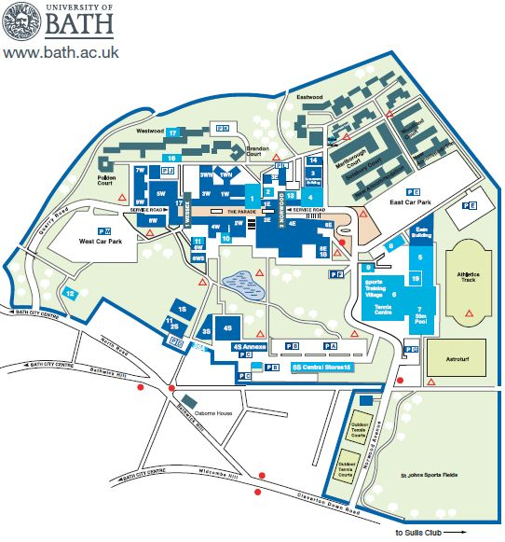

**Campus Map**

Pitches S = Sitec (A & B)

[](http://www.google.co.uk/imgres?imgurl=http://www.mearsgroup.co.uk/image/1524/medium&imgrefurl=http://www.mearsgroup.co.uk/page/scion-technical-home/scion-technical-specialist-services&h=479&w=473&sz=4&tbnid=io4Djm3iZ56CfM:&tbnh=90&tbnw=89&prev=/search?q=first+aid+logo&tbm=isch&tbo=u&zoom=1&q=first+aid+logo&usg=__Pk7JAS2UswG8C30OTd2q-kS6iuE=&docid=l79FjxvPh-ZPGM&sa=X&ei=ueDfUcLQNMvEsga_t4DoCA&sqi=2&ved=0CDsQ9QEwB)

[](http://www.google.co.uk/imgres?imgurl=http://www.mearsgroup.co.uk/image/1524/medium&imgrefurl=http://www.mearsgroup.co.uk/page/scion-technical-home/scion-technical-specialist-services&h=479&w=473&sz=4&tbnid=io4Djm3iZ56CfM:&tbnh=90&tbnw=89&prev=/search?q=first+aid+logo&tbm=isch&tbo=u&zoom=1&q=first+aid+logo&usg=__Pk7JAS2UswG8C30OTd2q-kS6iuE=&docid=l79FjxvPh-ZPGM&sa=X&ei=ueDfUcLQNMvEsga_t4DoCA&sqi=2&ved=0CDsQ9QEwB)

Cash Point

[](http://www.google.co.uk/imgres?imgurl=http://www.mearsgroup.co.uk/image/1524/medium&imgrefurl=http://www.mearsgroup.co.uk/page/scion-technical-home/scion-technical-specialist-services&h=479&w=473&sz=4&tbnid=io4Djm3iZ56CfM:&tbnh=90&tbnw=89&prev=/search?q=first+aid+logo&tbm=isch&tbo=u&zoom=1&q=first+aid+logo&usg=__Pk7JAS2UswG8C30OTd2q-kS6iuE=&docid=l79FjxvPh-ZPGM&sa=X&ei=ueDfUcLQNMvEsga_t4DoCA&sqi=2&ved=0CDsQ9QEwB)

[](http://www.google.co.uk/imgres?imgurl=http://www.mearsgroup.co.uk/image/1524/medium&imgrefurl=http://www.mearsgroup.co.uk/page/scion-technical-home/scion-technical-specialist-services&h=479&w=473&sz=4&tbnid=io4Djm3iZ56CfM:&tbnh=90&tbnw=89&prev=/search?q=first+aid+logo&tbm=isch&tbo=u&zoom=1&q=first+aid+logo&usg=__Pk7JAS2UswG8C30OTd2q-kS6iuE=&docid=l79FjxvPh-ZPGM&sa=X&ei=ueDfUcLQNMvEsga_t4DoCA&sqi=2&ved=0CDsQ9QEwB)

Sports Training Village First Aid Point Toilets

Free Space

Control Marquee First Aid Point Burger/Beer Van Stick Shop DJ Tent

Accommodation Office

Parade Bar

Bus Stop

**Important Addresses**

Bath Railway Station / Bus Station STV - University of Bath Bath Rugby Royal United Hospital Bristol Airport

Dorchester Street Claverton Spring Gardens Combe Park

Bath Bath Bath Bath Bristol

BA1 1SU BA2 7AY BA2 4DS BA1 3NG BS48 3DY

0845 700 0125 01225 384454 01225 325200 01225 428331 0871 3344444

**Local Map** 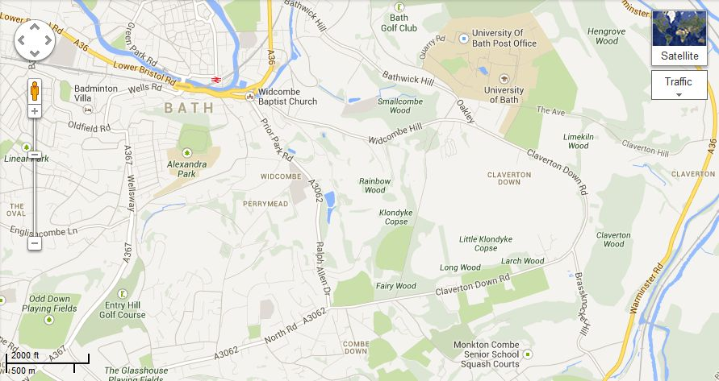

Norwood Avenue

Sports Training Village

University of Bath Claverton Bath BA2 7AY

Bath Railway and Bus station

Dorchester Street Bath BA1 1SU

Bath Rugby

Spring Gardens Bath BA2 4DS