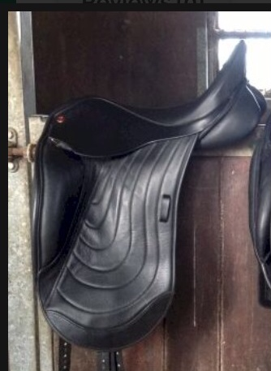

Comfort Elite Candence Dressage Saddle

